Approved by AICTE , New Delhi & Accredited By ISO 9001:2015 Certified Institution , Accredited BY NAAC With “A” Grade

173,Agaram Road, Selaiyur, Chennai-600073,Tamil Nadu, India.

 **AN INTERNSHIP REPORT**

SUBMITTED BY  
  
DANDOTHIYA GOPESH SHARMA   
(U22AI016)

Under the Guidance of

Ms.R.Divya Lakshmi

Subject Specialist  
  
**BACHELOR OF ENGINEERING**

**IN**  
**COMPUTER SCIENCE AND ENGINEERING – ARTIFICIAL INTELLIGENCE**

**JULY-2025**

Approved by AICTE , New Delhi & Accredited By ISO 9001:2015 Certified Institution , Accredited BY NAAC With “A” Grade

 173,Agaram Road, Selaiyur, Chennai-600073,Tamil Nadu, India. ** BONFIDE CERTIFICATE**This is to Certify that the Internship at **“NSIC – TECHNICAL SERVICES CENTRE”** by **DANDOTHIYA GOPESH SHARMA**, who carried out the Internship under my supervision. Certified further that to the best of my Knowledge the work reported here does not form part of any other training report or dissertation on the basis of which a degree or award was conferred on an occasion on this or any other candidate.

**INTERNAL GUIDE HEAD OF THE DEPARTMENT**

**DECLARATION**

This is to declare that **DANDOTHIYA GOPESH SHARMA**, student of

4th year B.TECH (CSE-AI), Bharath Institute of Higher Education and Research, has undergone “**Internship Training on Cloud Computing** “ conducted by

NSIC – TECHNICAL SERVICES CENTRE for a Period of 2 weeks from

30-06-2025 to 11-07-2025.  
  
  
  
  
  
**Place :** Chennai **Date :** 11-07-2025

**A.ARUL PRABAHAR**

DEPUTY MANAGER - NSIC



**NSIC**

**National Small Industries Corporation**

**2 Week Internship Program**

**On**

**Cloud Computing**

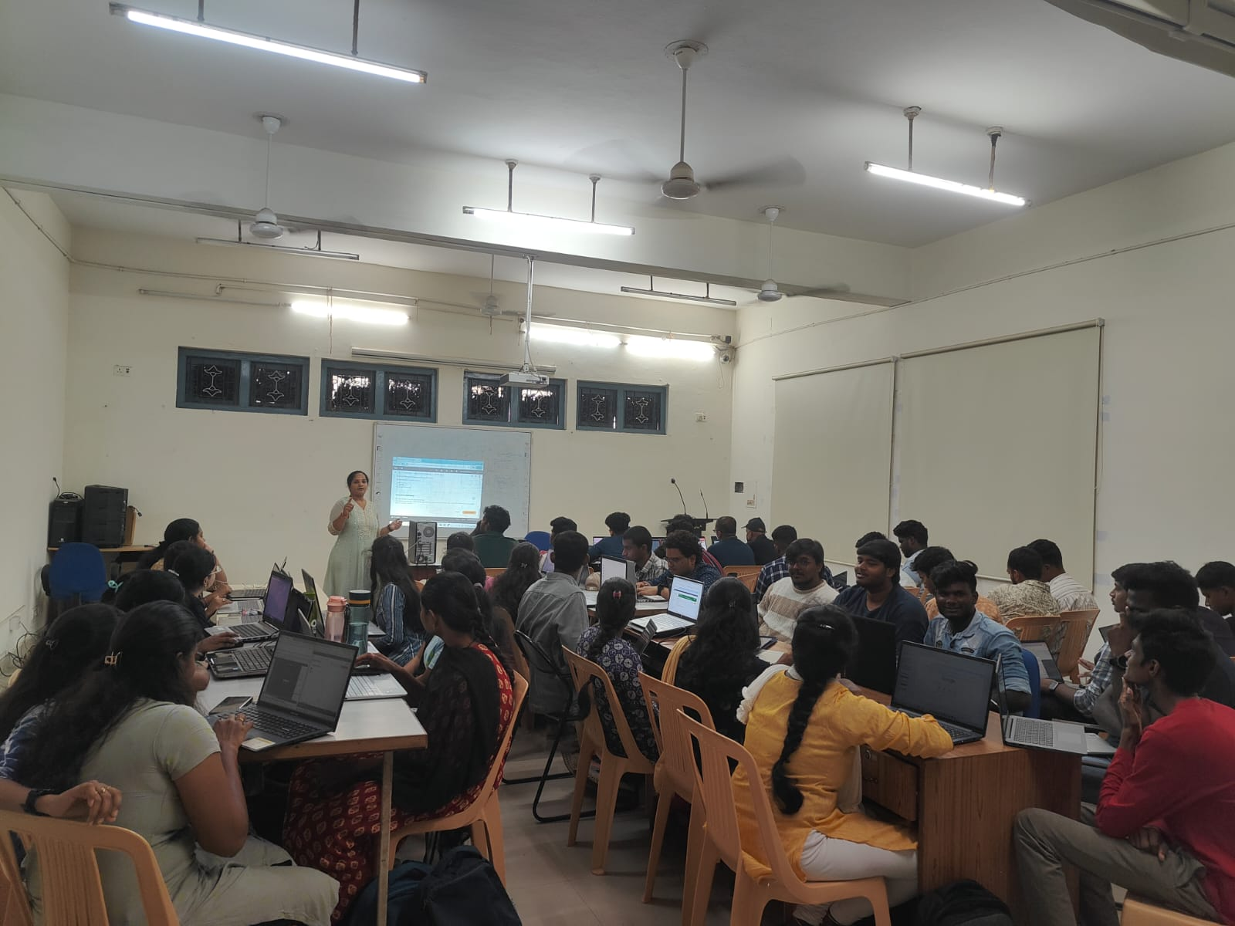

**INTRODUTION**

In the Quest to develop my knowledge and gain invaluable industry experience,   
I , DANDOTHIYA GOPESH SHARMA, pursued a comprehensive internship as part of my Cloud Computing course. The Two-Weeks Internship, from 30th June 2025 to 11th July 2025, was undertaken at the esteemed National Small Industries Corporation (NSIC) Technical Service Centre.   
  
The NSIC- Technical Services Centre (NTSC), Chennai established in the year 1976 the support existing and aspiring entrepreneurs of the MSME Sector in the Southern region by providing skilled manpower and testing services through its various skill development training programs and testing facilities in the area, Motor, Pump and engine etc., which are NABL accredited and BIS recognized. The Centre also provides support to the MSME sector through its various commercial schemes like SPRS, Infomediary, etc., besides carrying out energy audit services as one of the certified authorized Auditors to carry out energy audits by the Government of India under the Ministry of Power.

**OBJECTIVE**

* To acquire hands-on experience in deploying and managing scalable applications using Cloud Computing platforms such as AWS.
* To understand and implement core cloud services including compute, storage, networking, and databases for real-world applications.
* To collaborate with professionals in cloud-based environments to gain insight into DevOps practices, CI/CD pipelines, and infrastructure as code (IaC).
* To explore current trends such as serverless computing, edge computing, and container orchestration, and evaluate their impact on modern cloud solutions.
* To contribute effectively to cloud-related projects by enhancing technical proficiency, optimizing cloud resource usage, and developing secure, cost-efficient cloud architectures.

**Day – 1 (30-06-2025)**

Introduction to Cloud Computing

Types of Cloud: Public (AWS, GCP) Private (OpenStack) Hybrid (combination)

Service Models: IaaS: Infrastructure as a Service (OpenStack, AWS EC2) PaaS: Platform as a Service (Heroku, OpenShift) SaaS: Software as a Service (Gmail, Nextcloud)

Benefits: Scalability, Cost-efficiency, Flexibility

**Day -2 (01-07-2025)**

Hands-On Task: Draw Cloud Architecture using draw.io OR Explore OpenStack

demo: <https://try.openstack.org>

✅ Steps:

Open the Tool

* Visit: https://app.diagrams.net
* Choose "Device" or "Google Drive" to save your diagram.
* Create a new diagram
* Name your diagram: Basic Cloud Architecture

Connect Components: Use arrows to show data flow

● Example: Client → Load Balancer → Web Server → App Server → DB

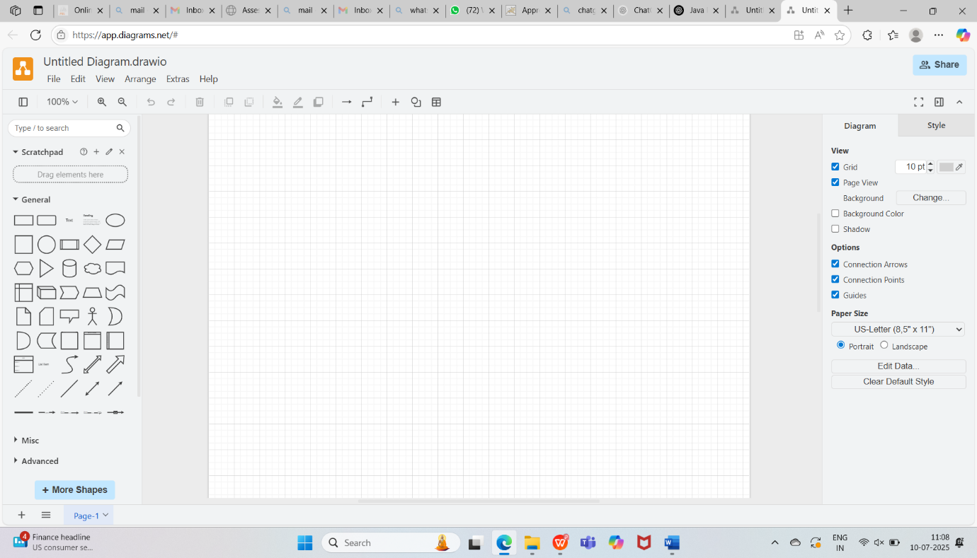

Label Each Component:

Add simple text labels like "IaaS", "PaaS", or "SaaS"

Save & Export: File → Export as PNG or PDF

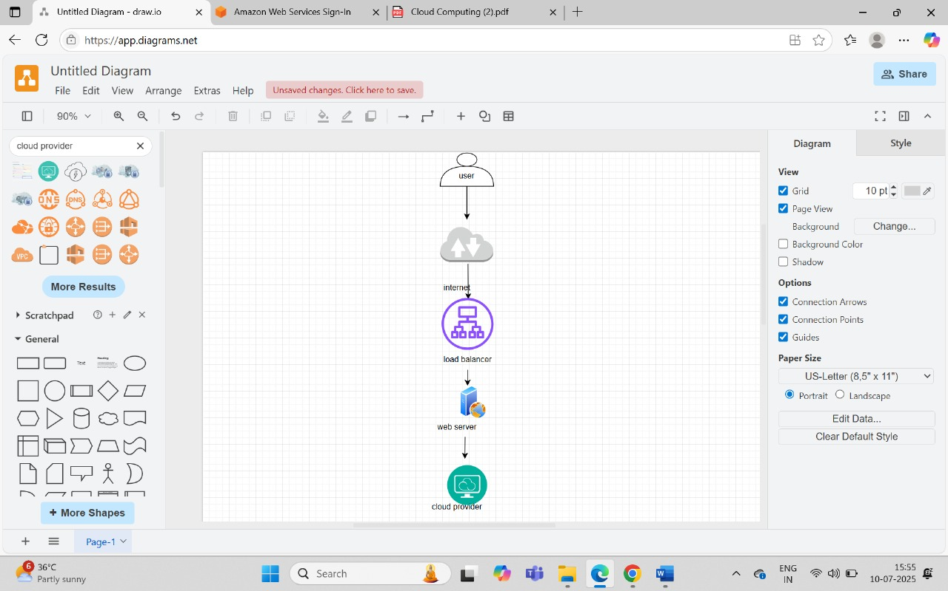

Basic Architecture Cloud

Downloaded Oracle Virtual Box And Ubuntu :

Oracle VirtualBox (Download: <https://www.virtualbox.org/>)

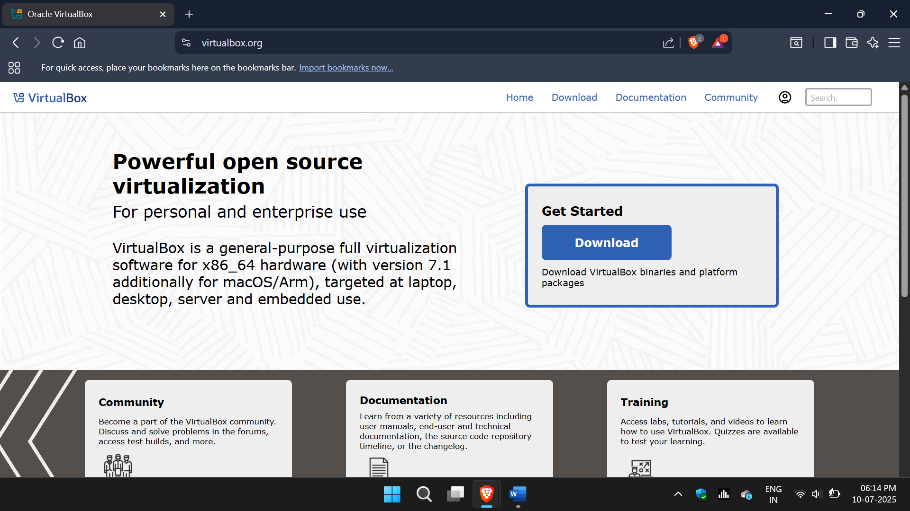

Ubuntu ISO file (Ubuntu Server or Desktop – Recommended: Ubuntu 22.04 LTS)

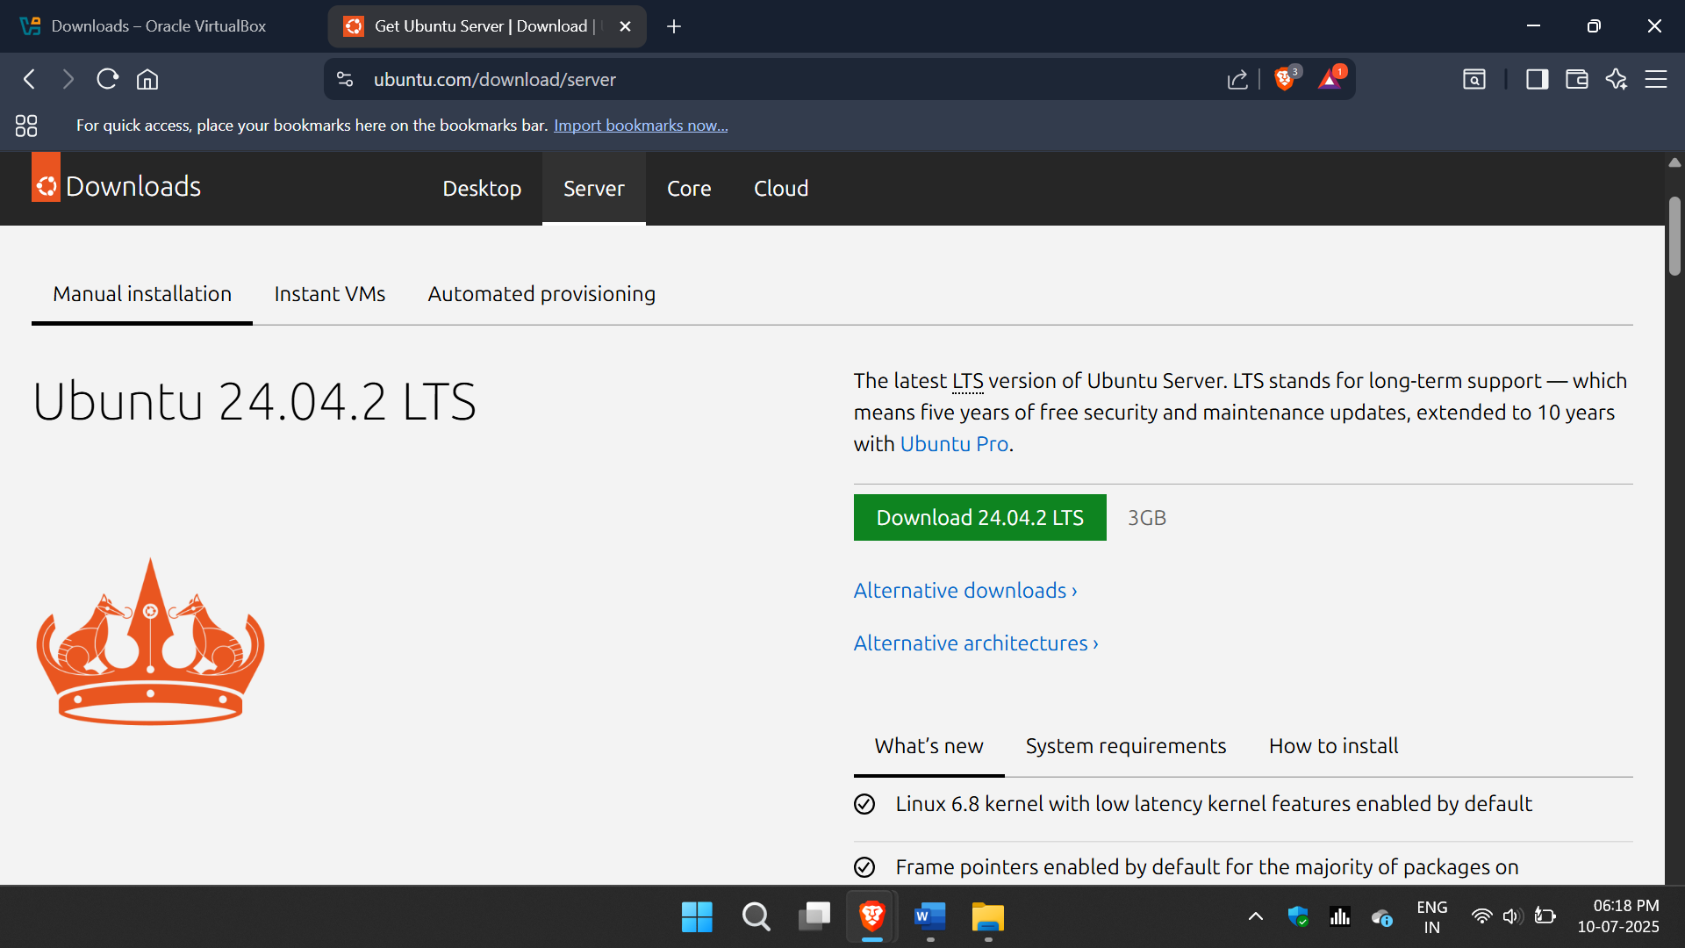

Download: <https://ubuntu.com/download/server> or <https://ubuntu.com/download/desktop>

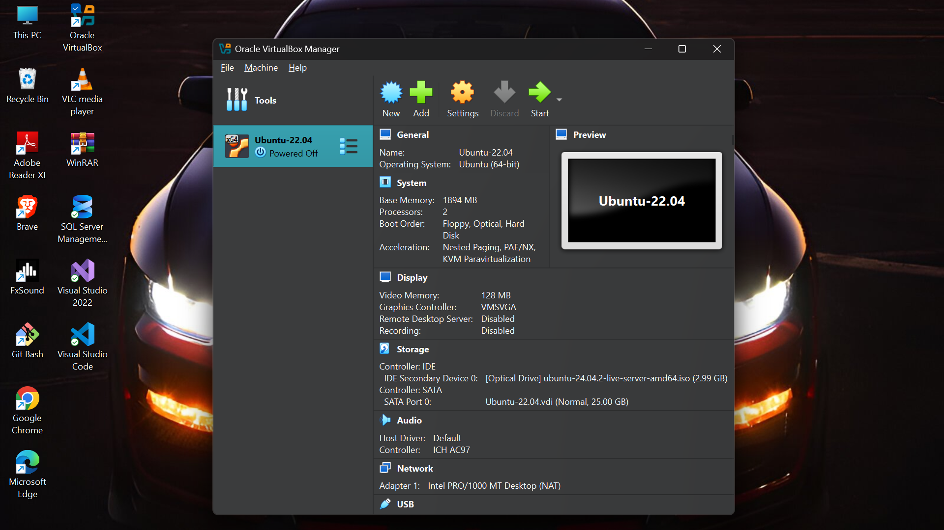

**Day-3 (02-07-2025)**

Cloud Computing – Advantages, Types, Service Models,

Cloud Providers

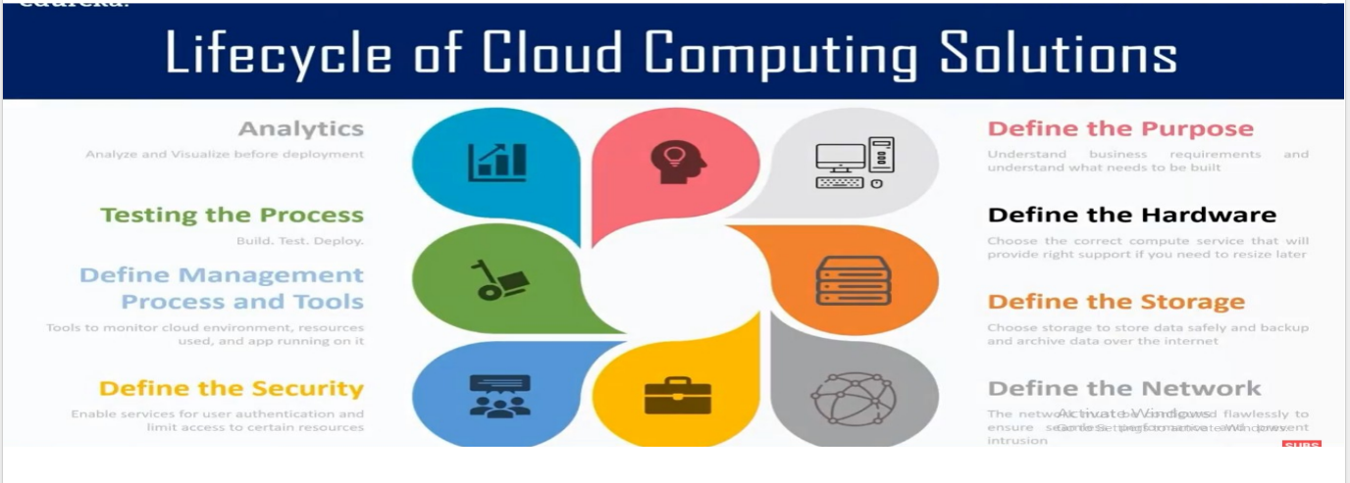

Introduction To AWS –

Market Surveys, Service Comparision, Benefits

Types of deployment models – Public ,Private , Hybrid cloud

Demo, Creating AWS Account

Creating Instances, EC2, Virtual Server



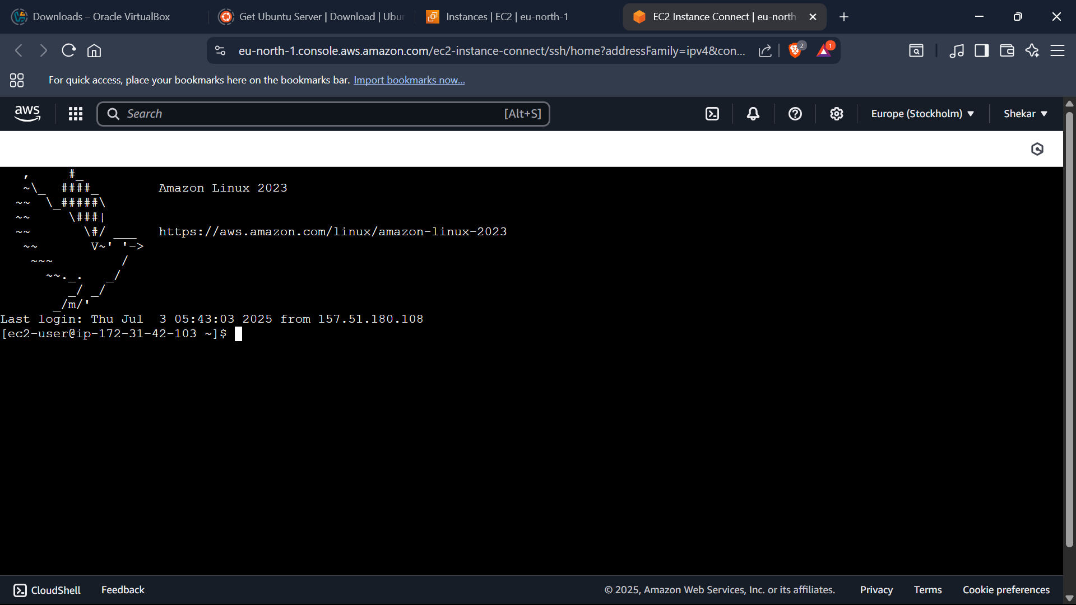

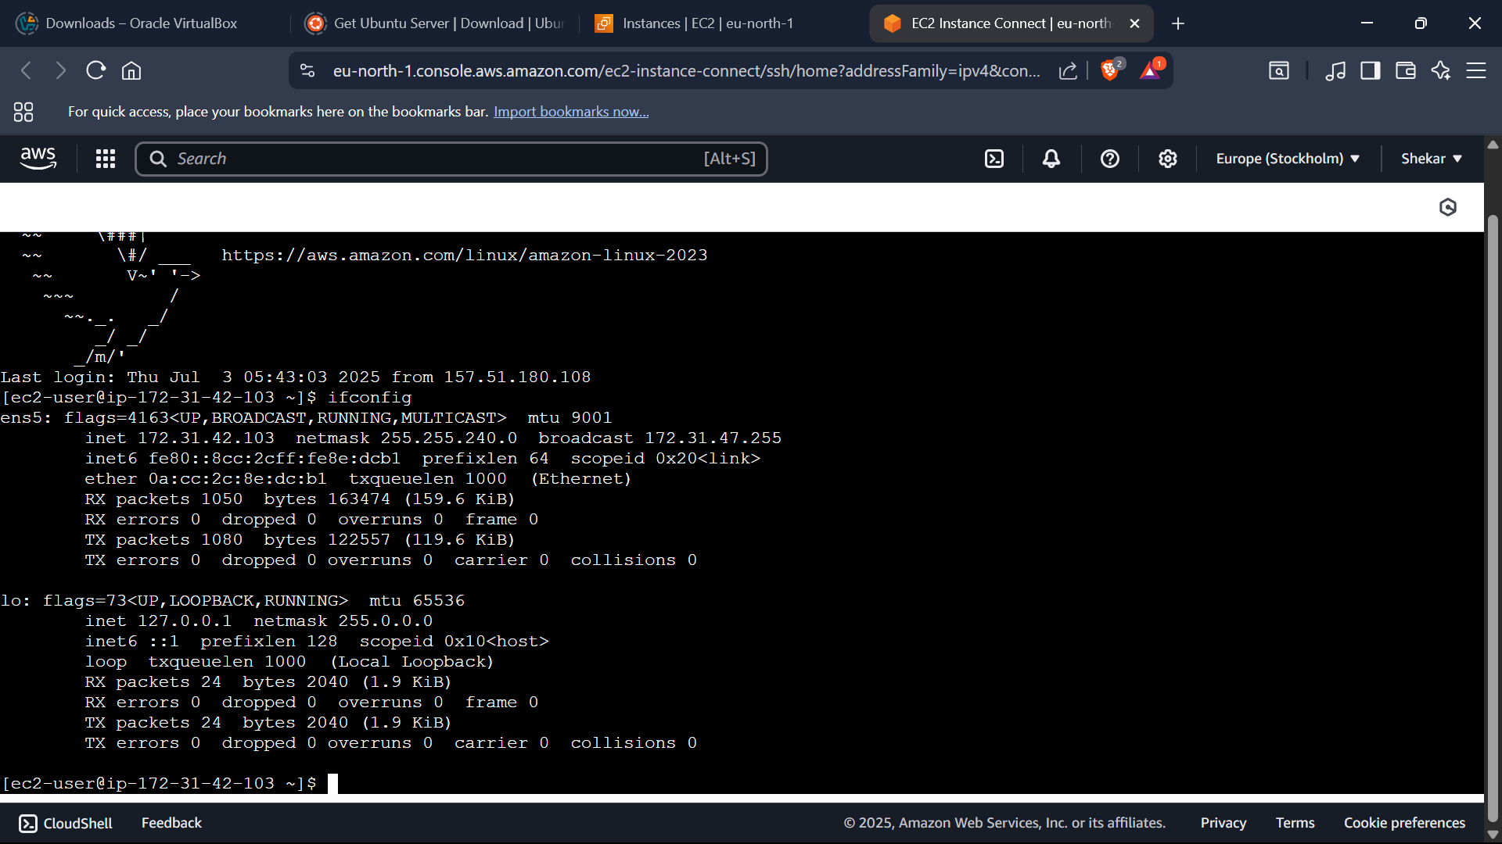

**Day - 4 (03-07-2025)**

Connecting instance with SSH Client

Creating A Bucket -

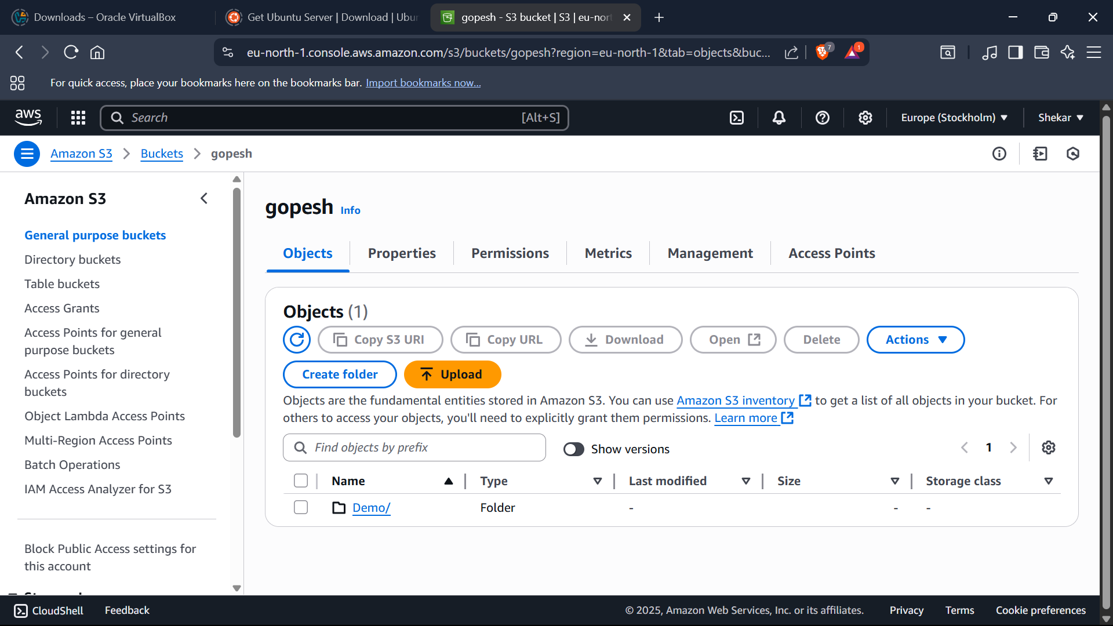

Creating a folder in S3 bucket

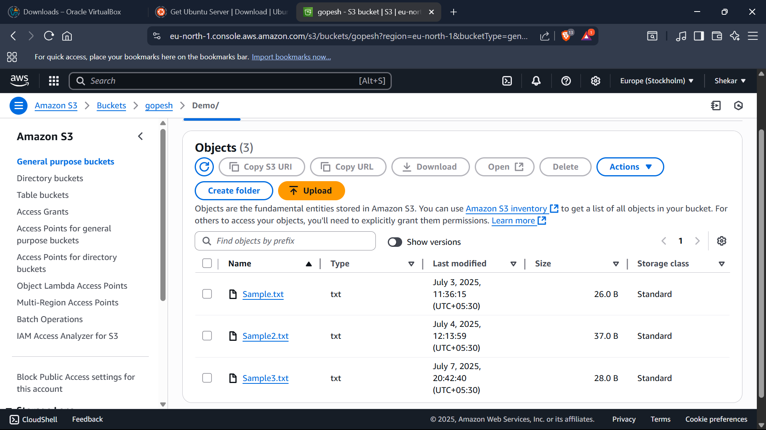

Creating file in a S3 Bucket folder-

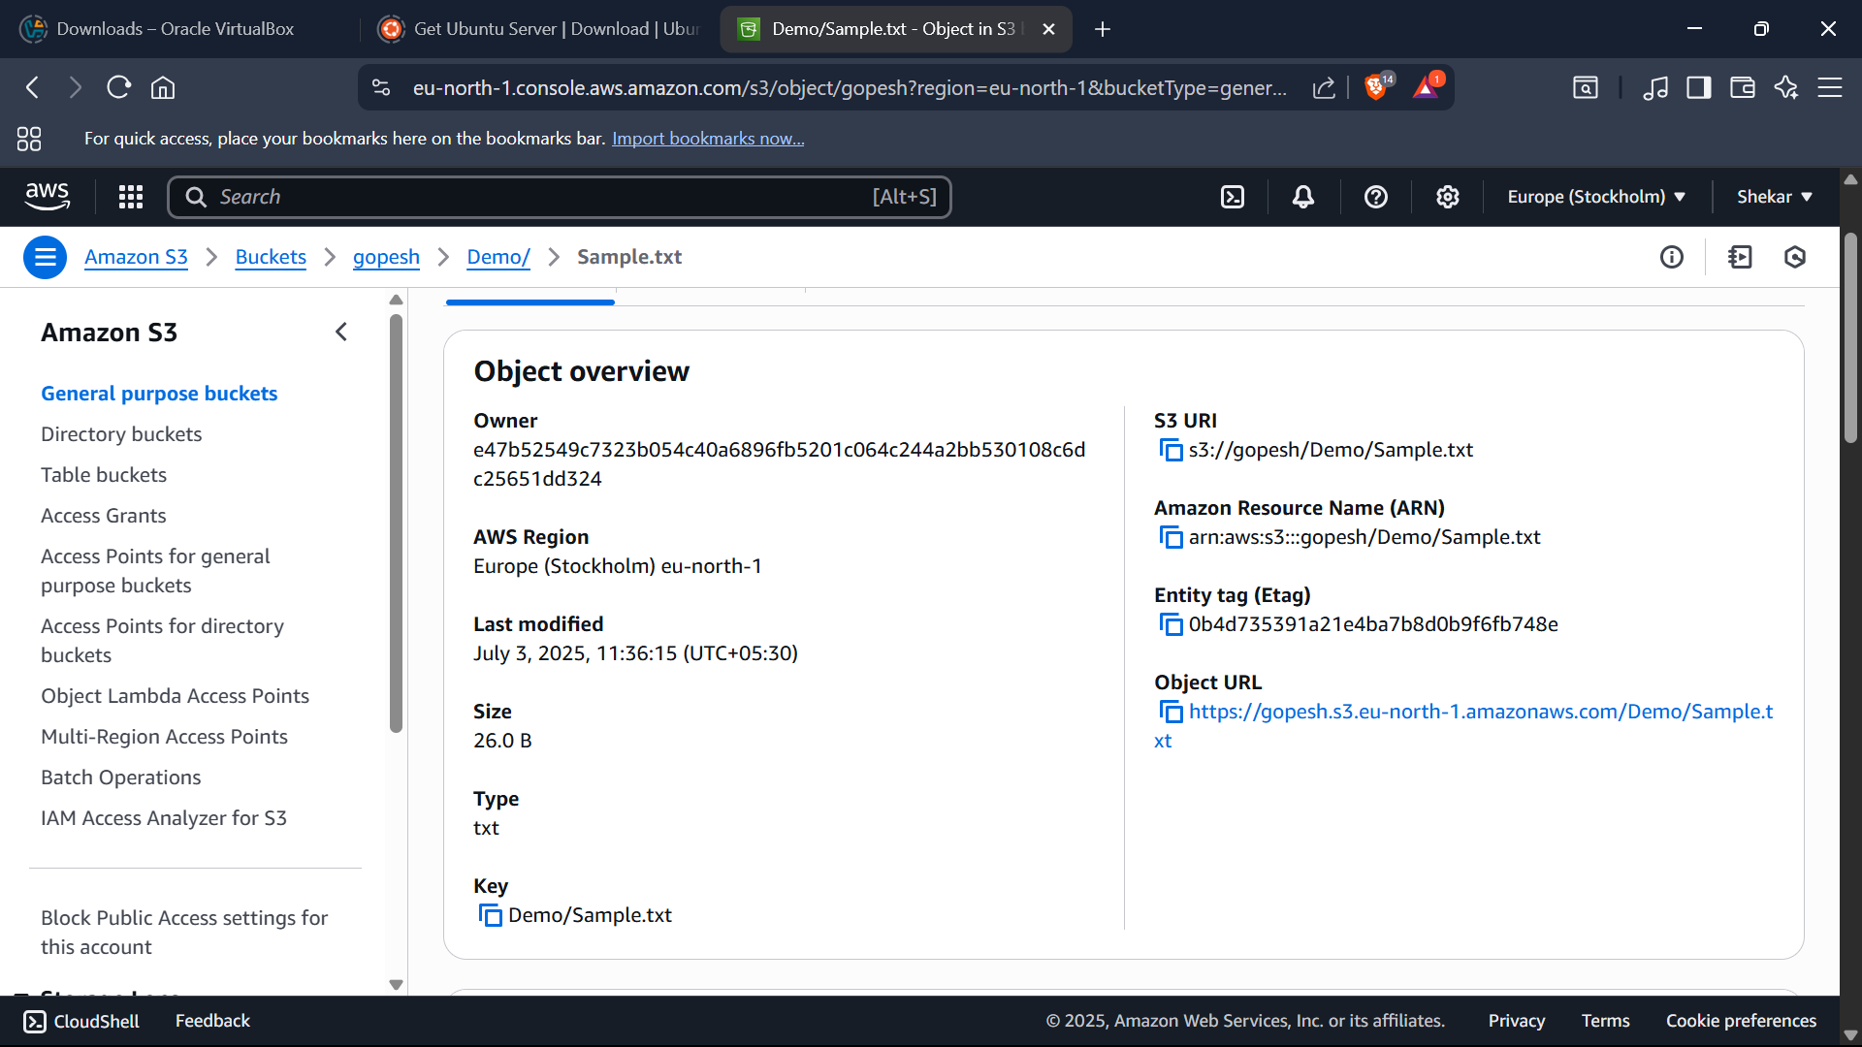

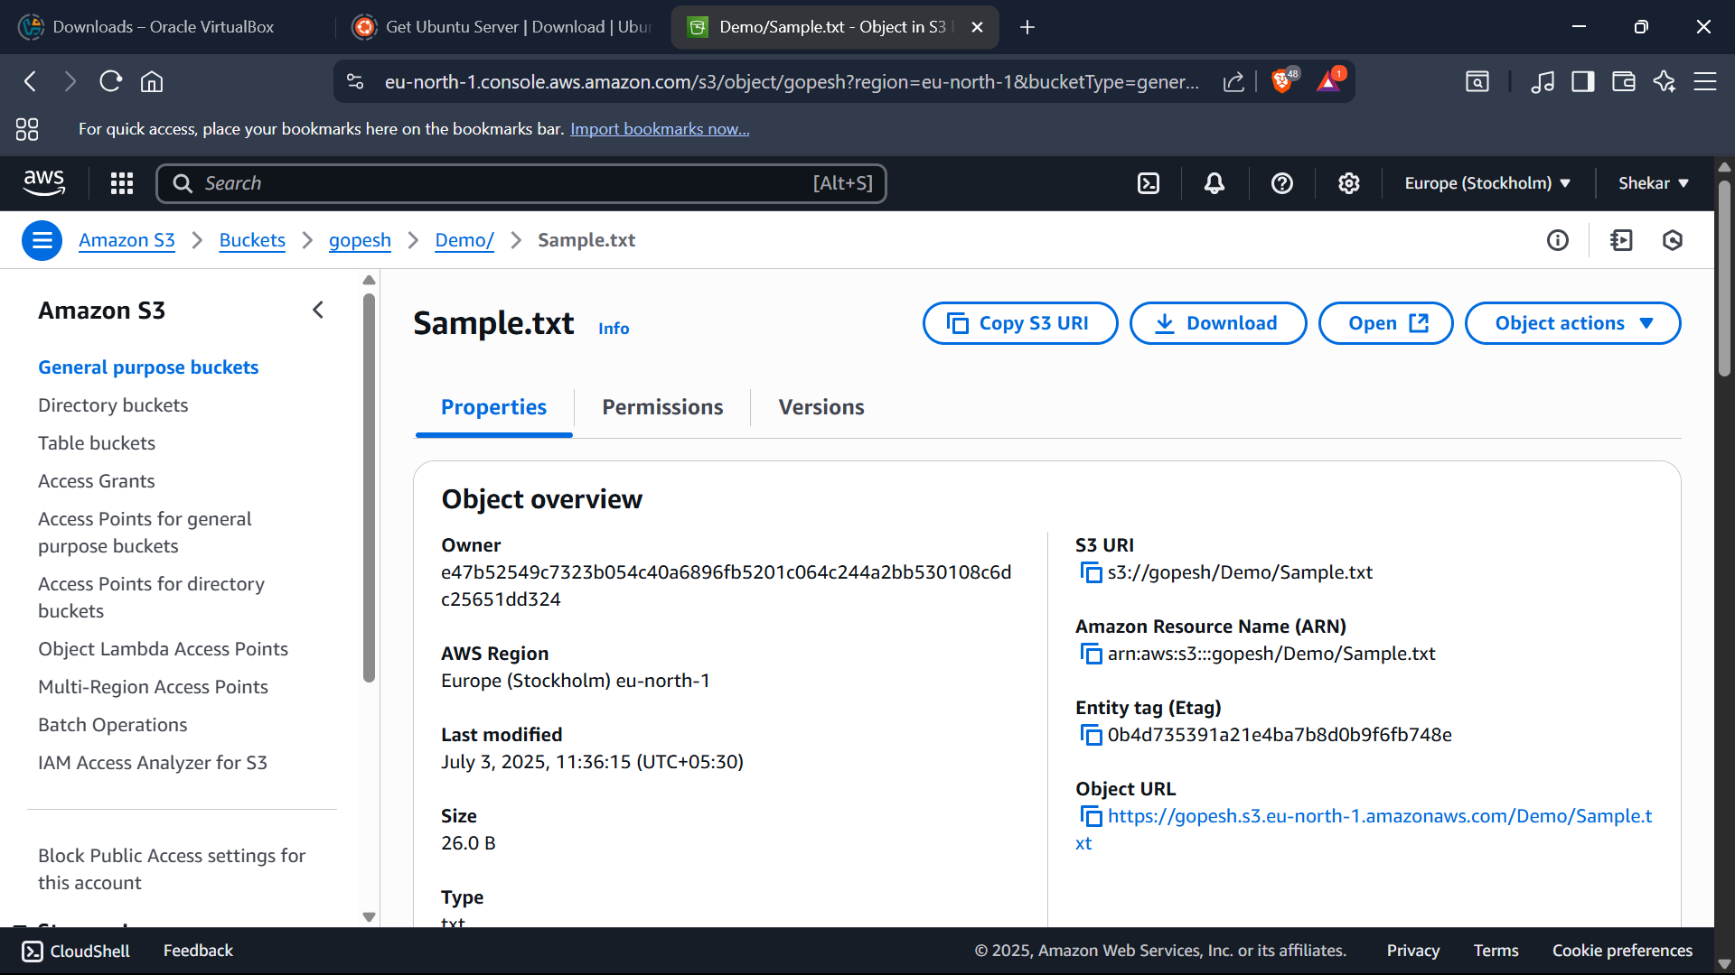

Editing Permissions in a bucket-

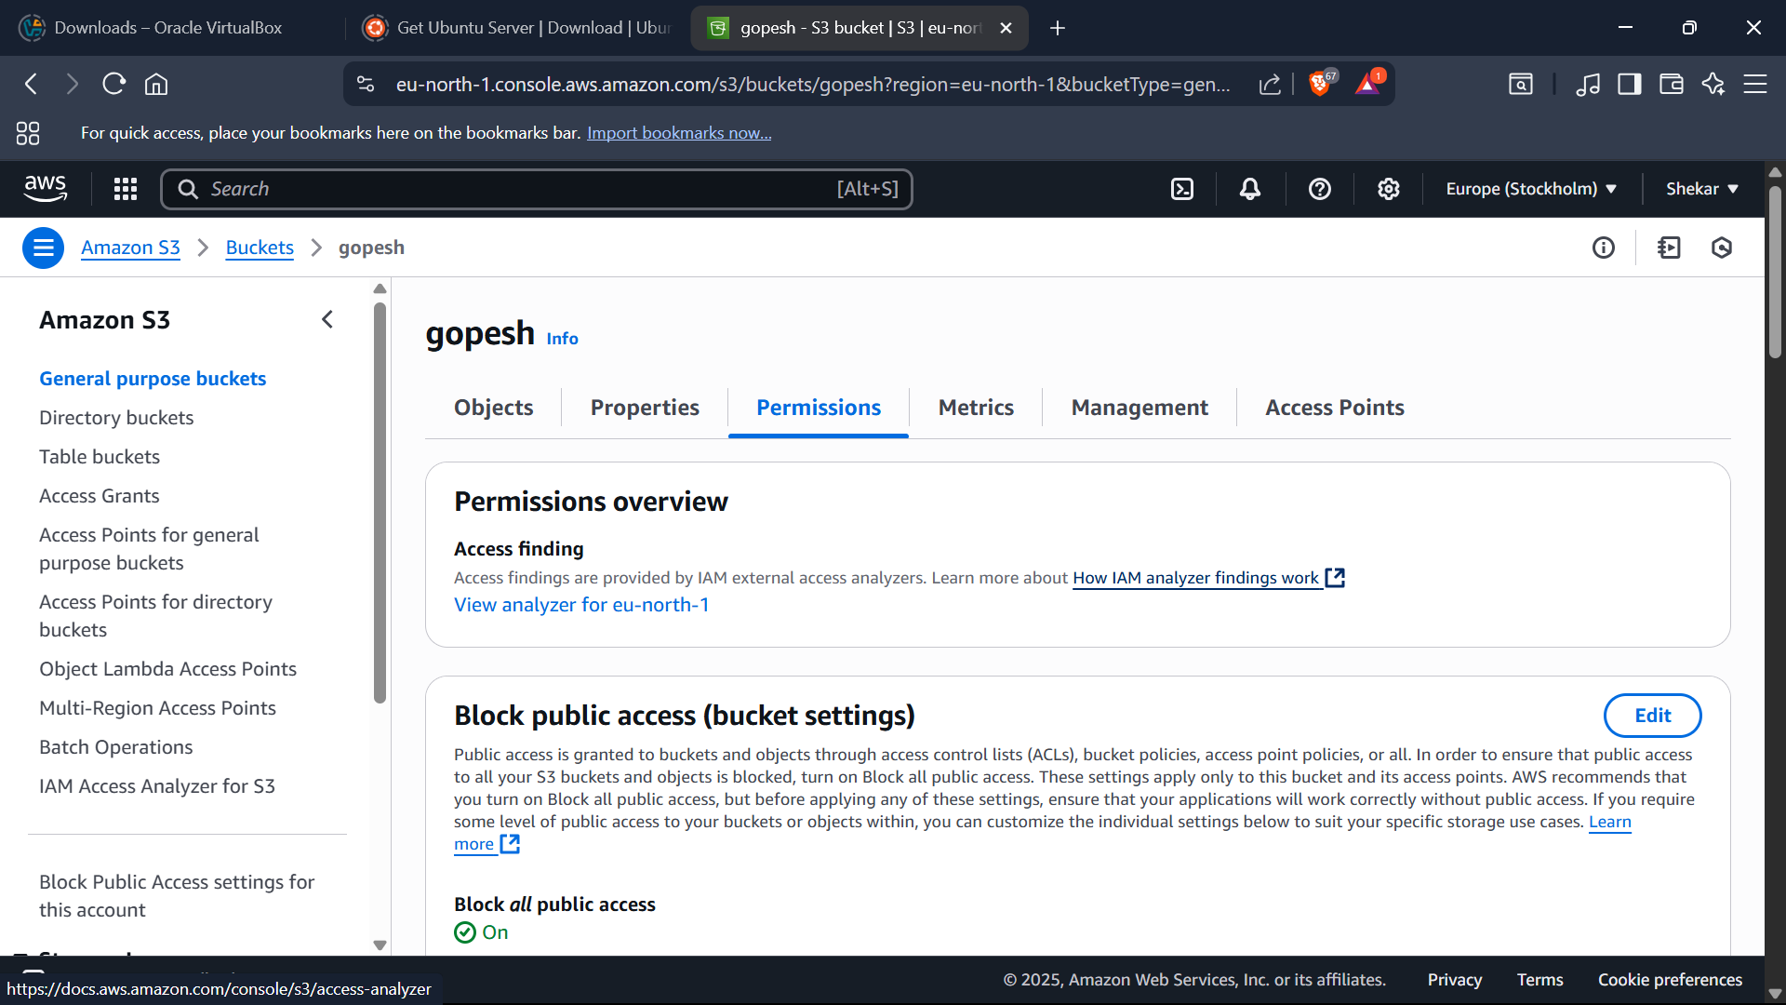

Blocking Public Access

Editing object ownership-

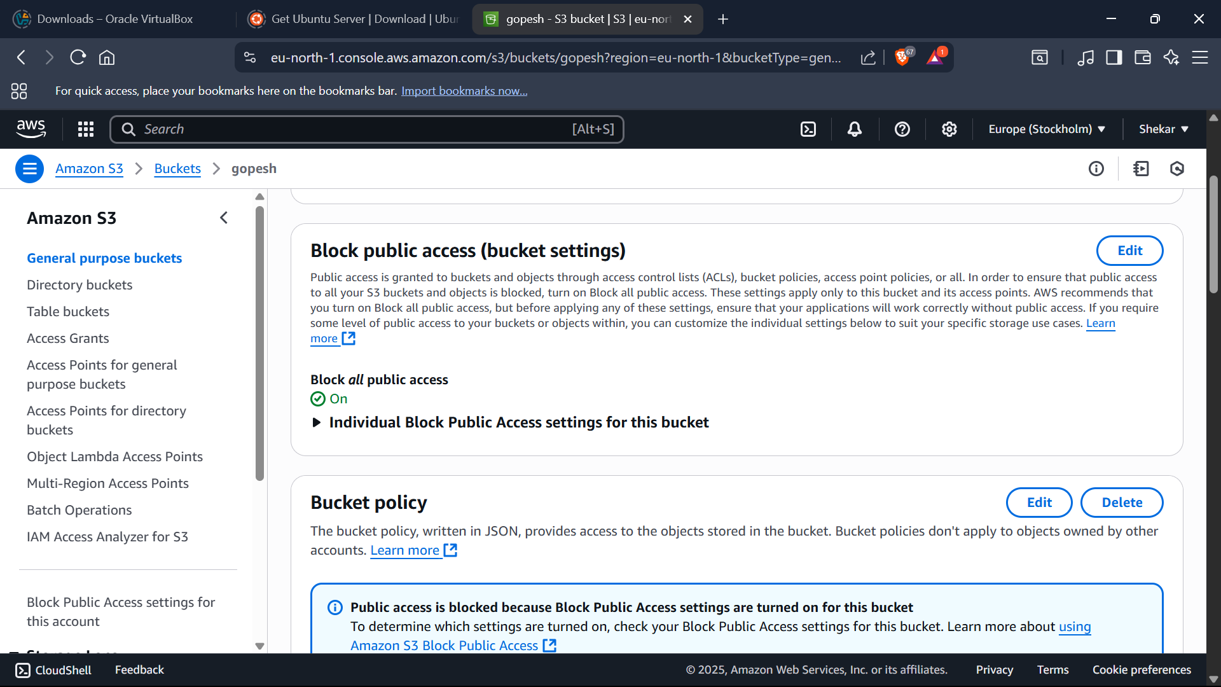

Editing block public access-

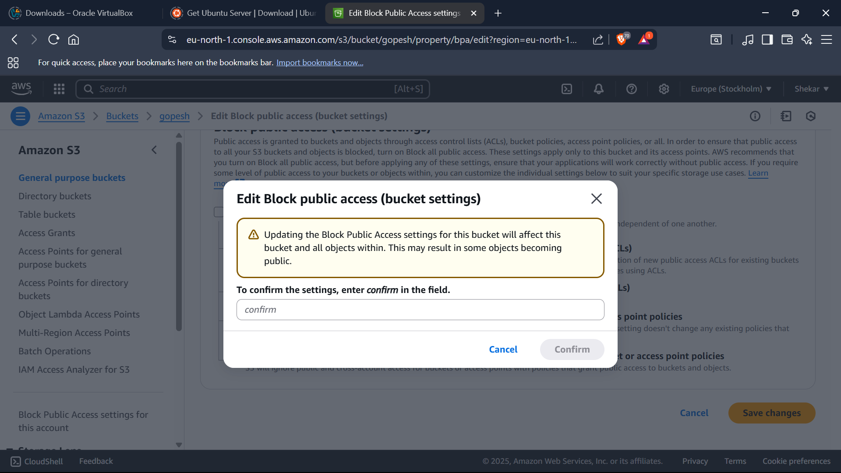

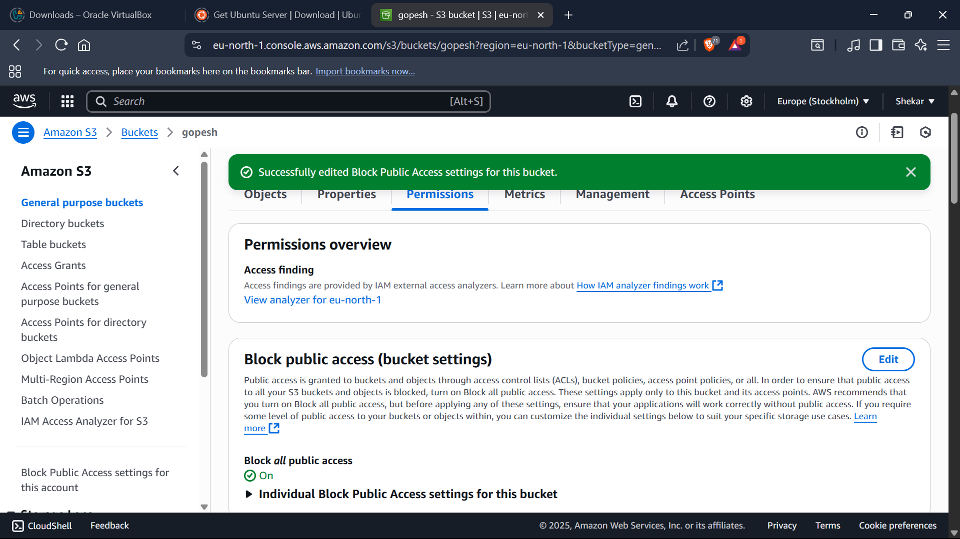

Editing access control list of an object-

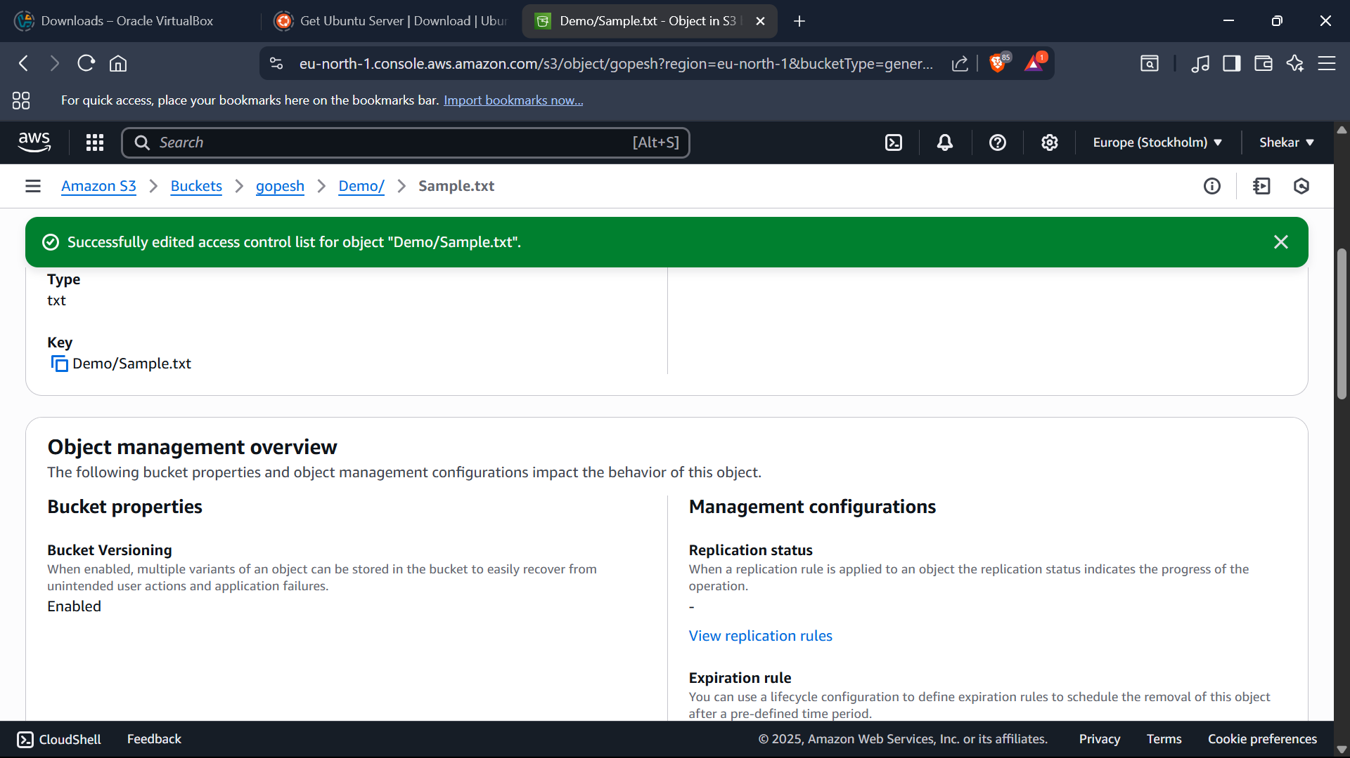

Edited Access Control List For Object:

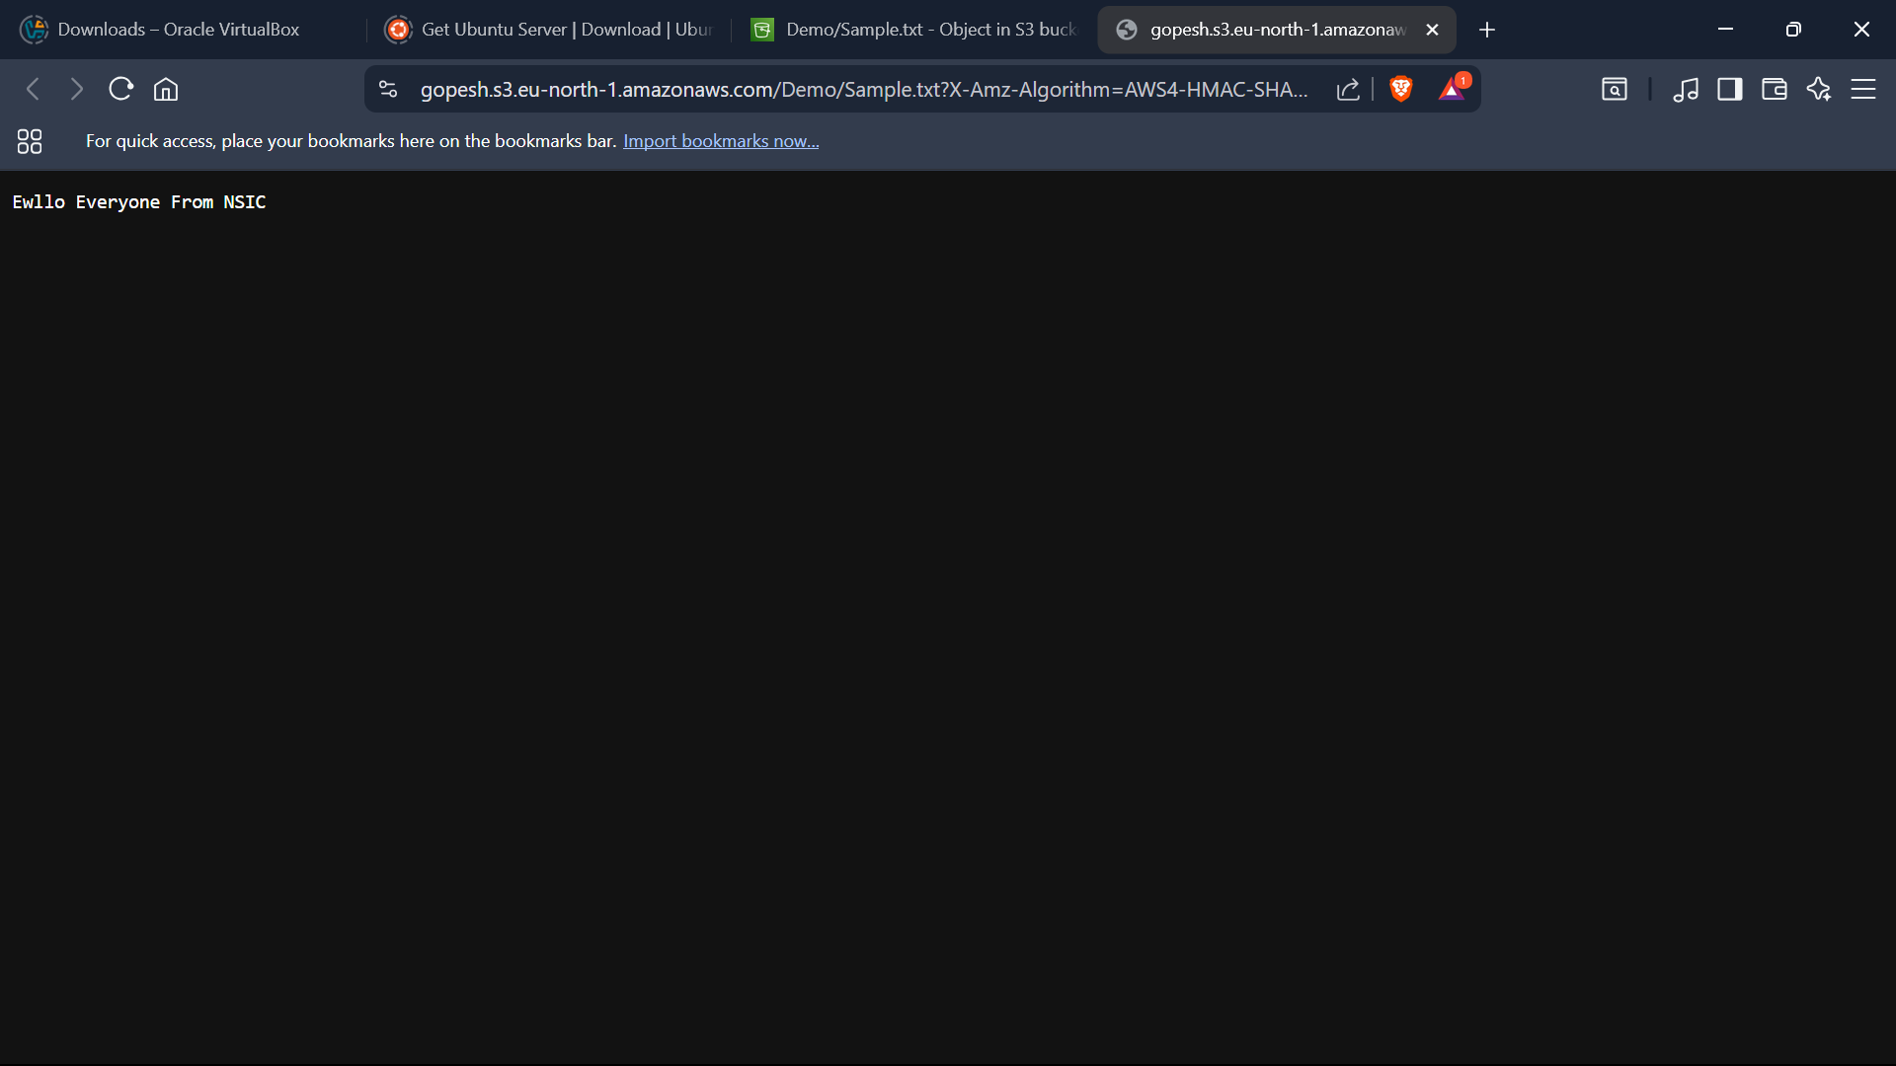

Check the bucket versioning:

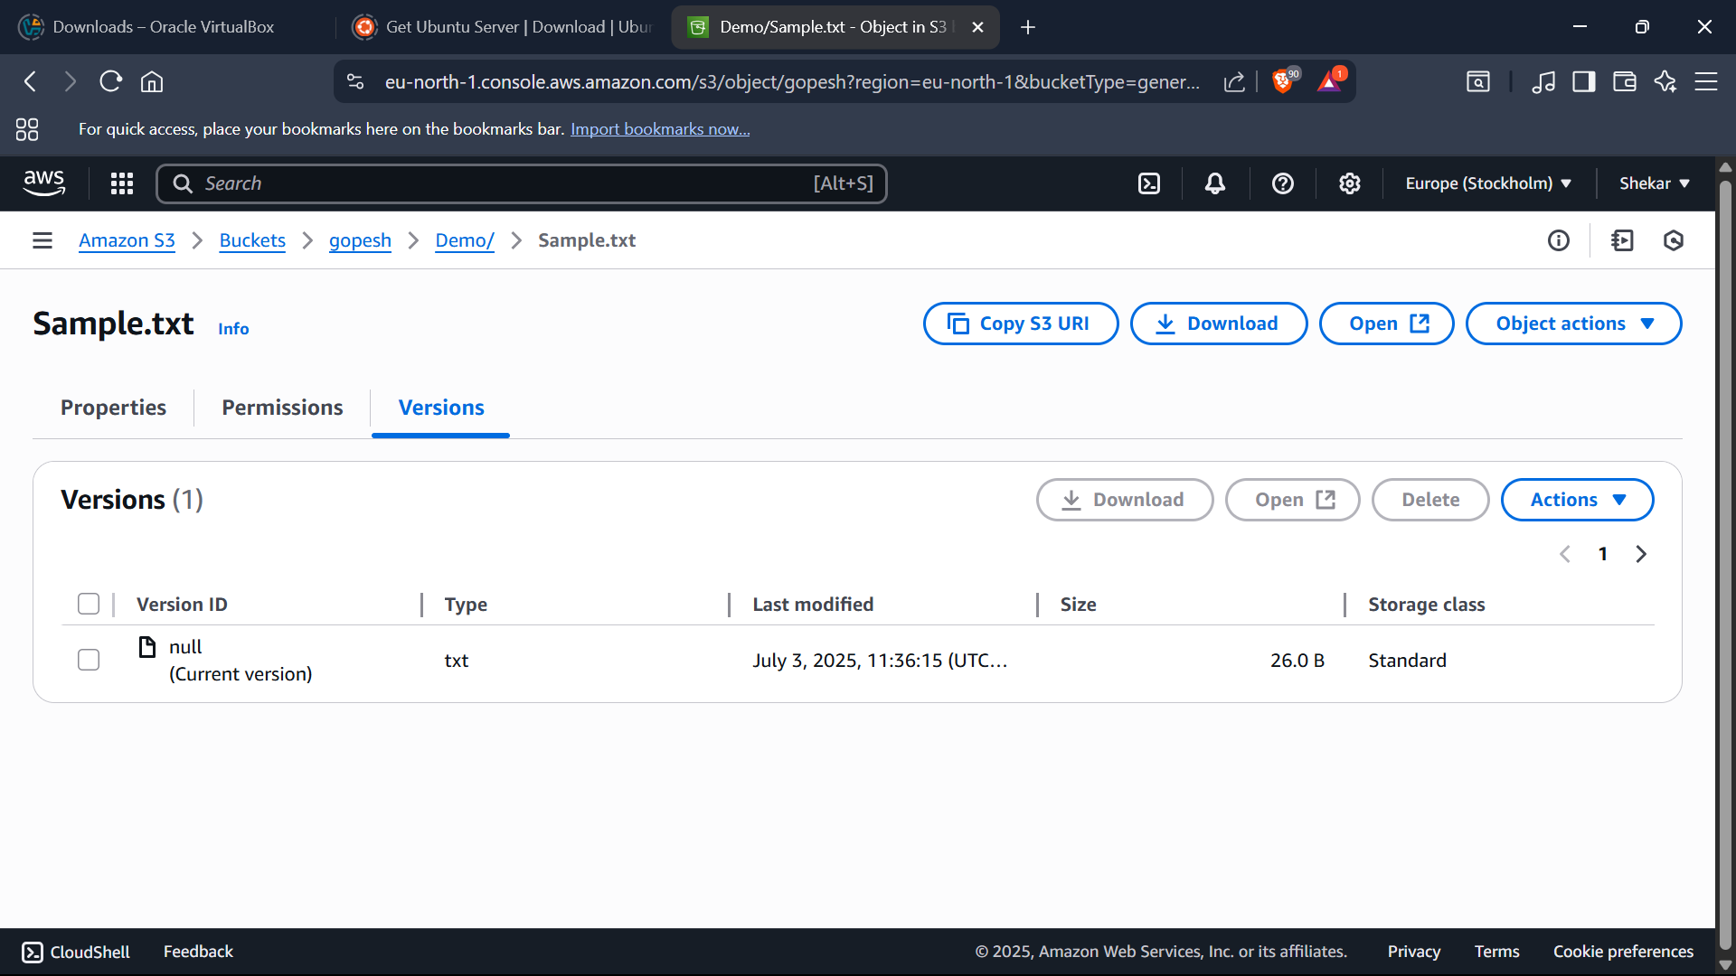

Editing the bucket versioning:

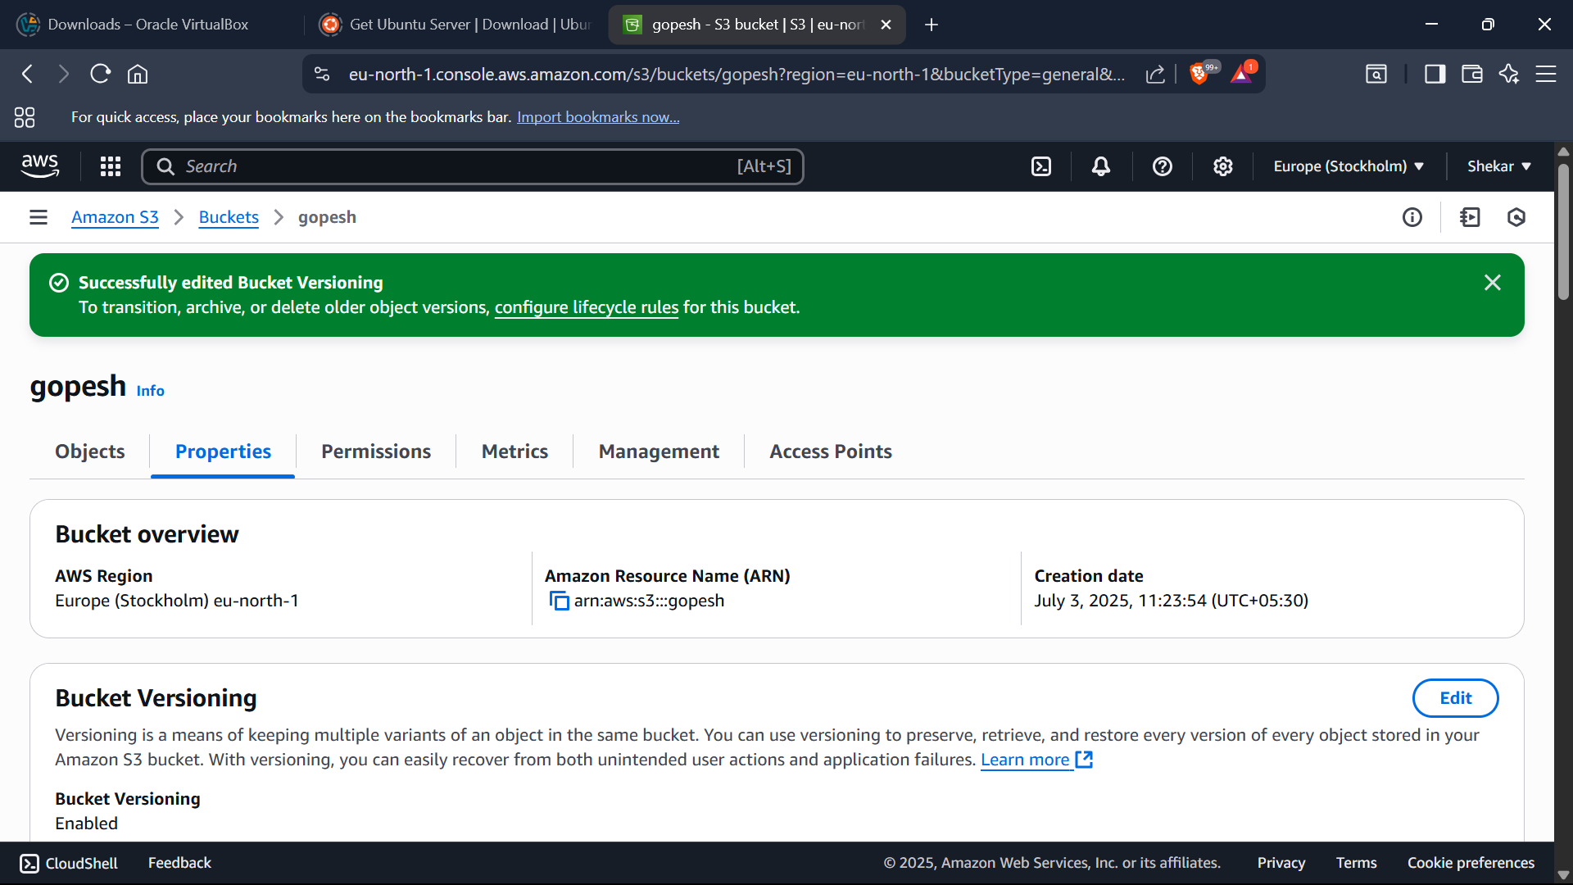

Creating IAM User-

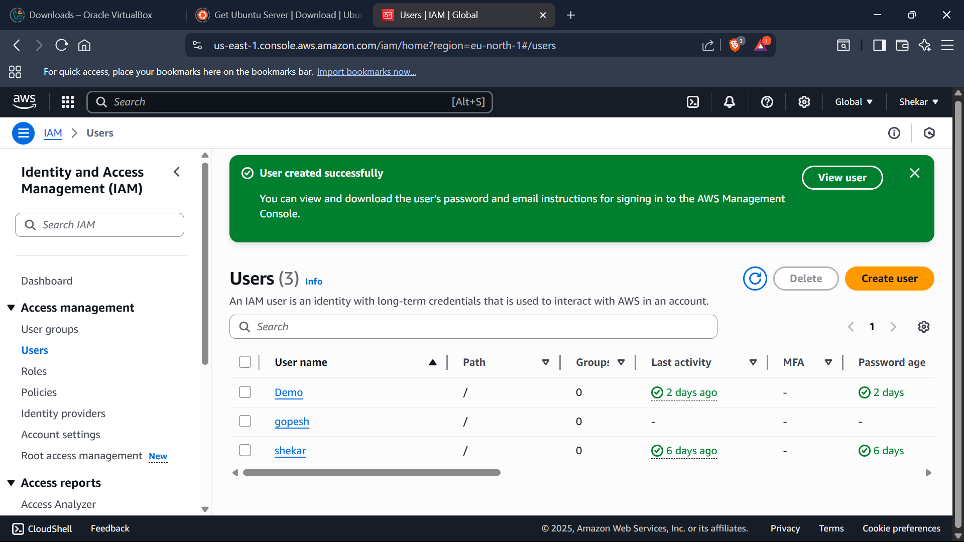

Creating bucket is failed in S3 due to denied access to IAM User

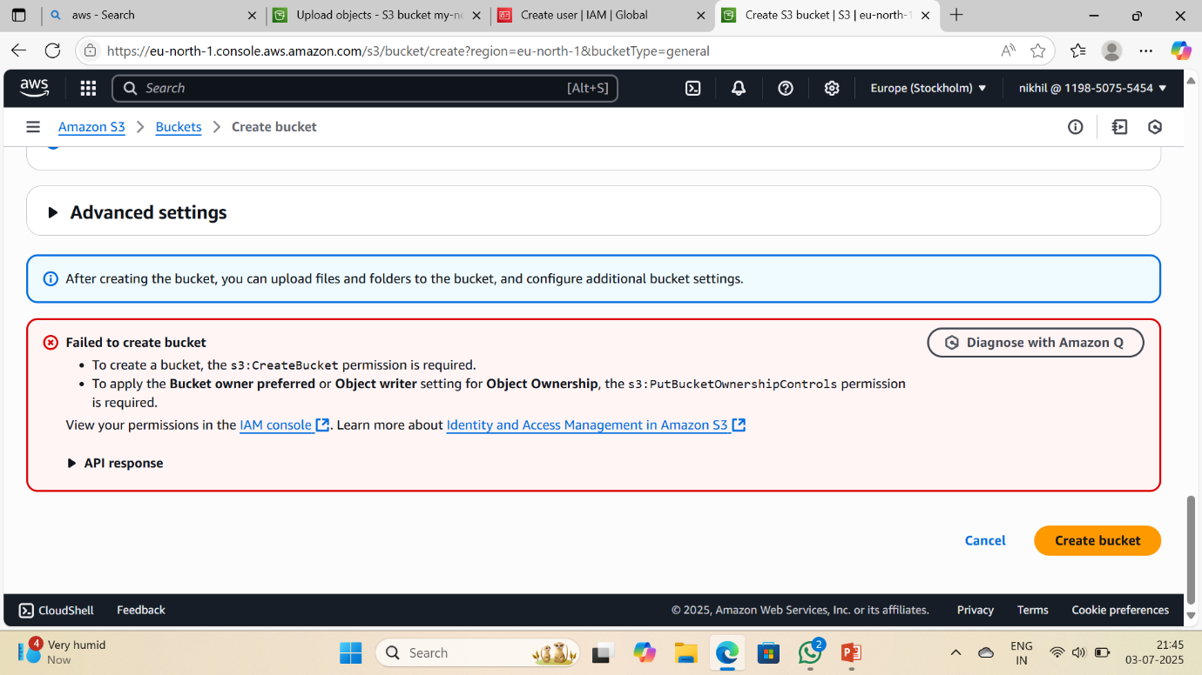

Creating own policy for IAM-

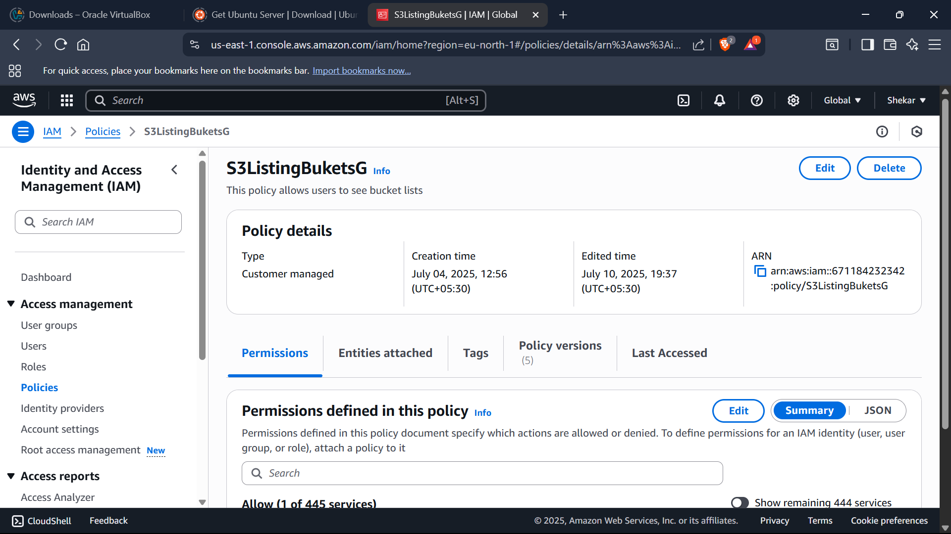

Created my own policy and named it as “licpolicy”

Attaching policy to the IAM User-

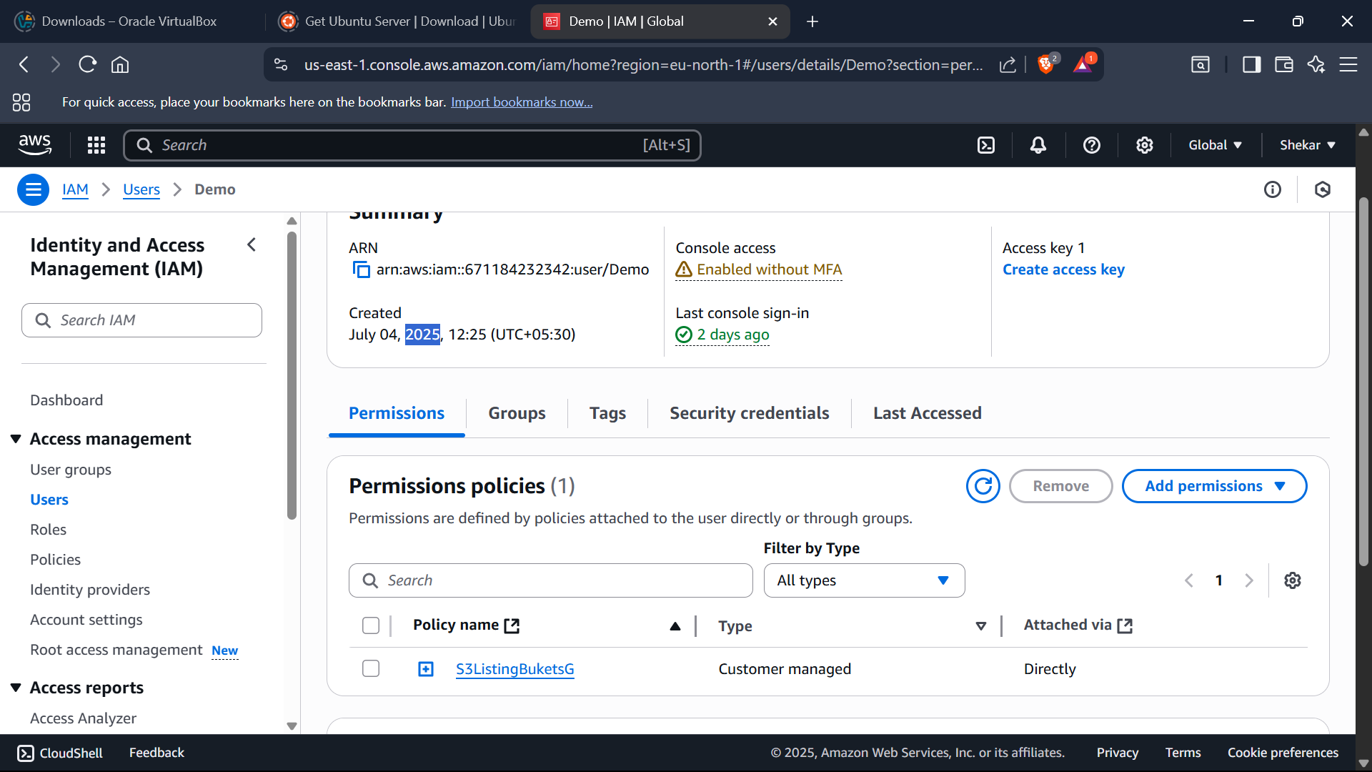

**Day-5 (04-07-2025)**

Updating policy-

After updating policy, file uploading is failed in IAM User due to denied access.

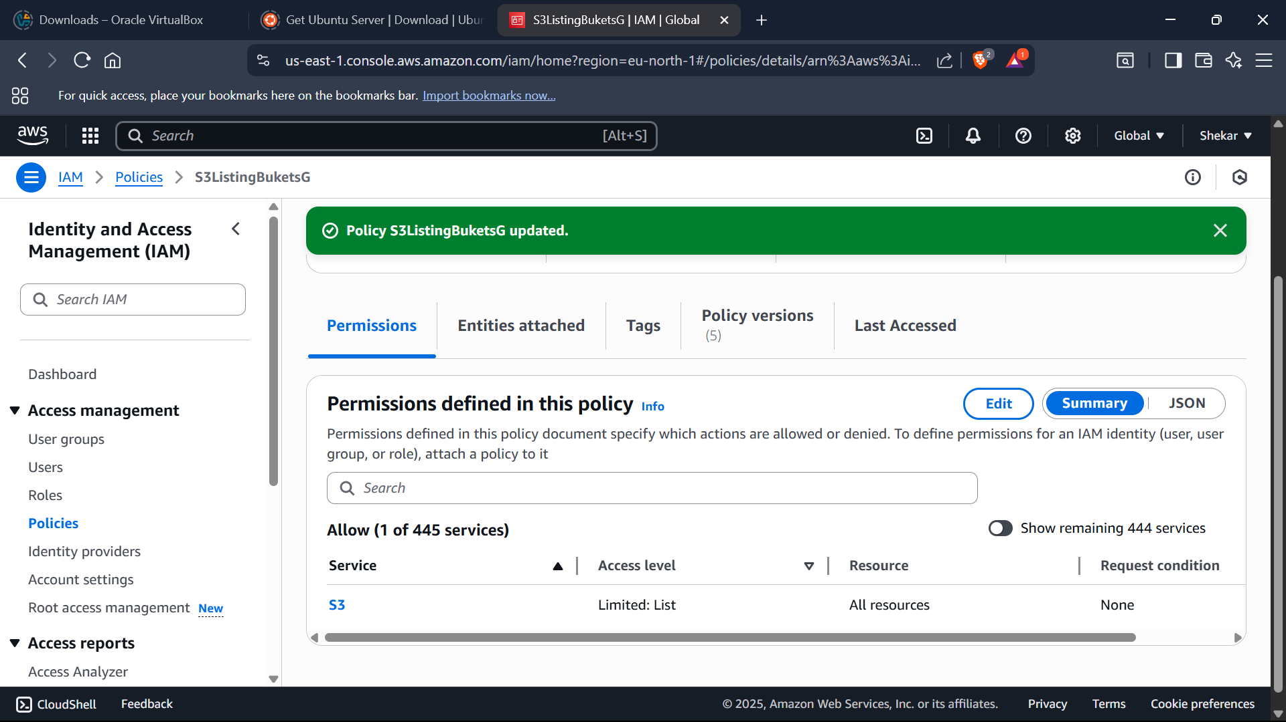

Again updating permission in policy (Root user)-



After updating policy permission in root user, files will be uploaded to the IAM user without any errors.

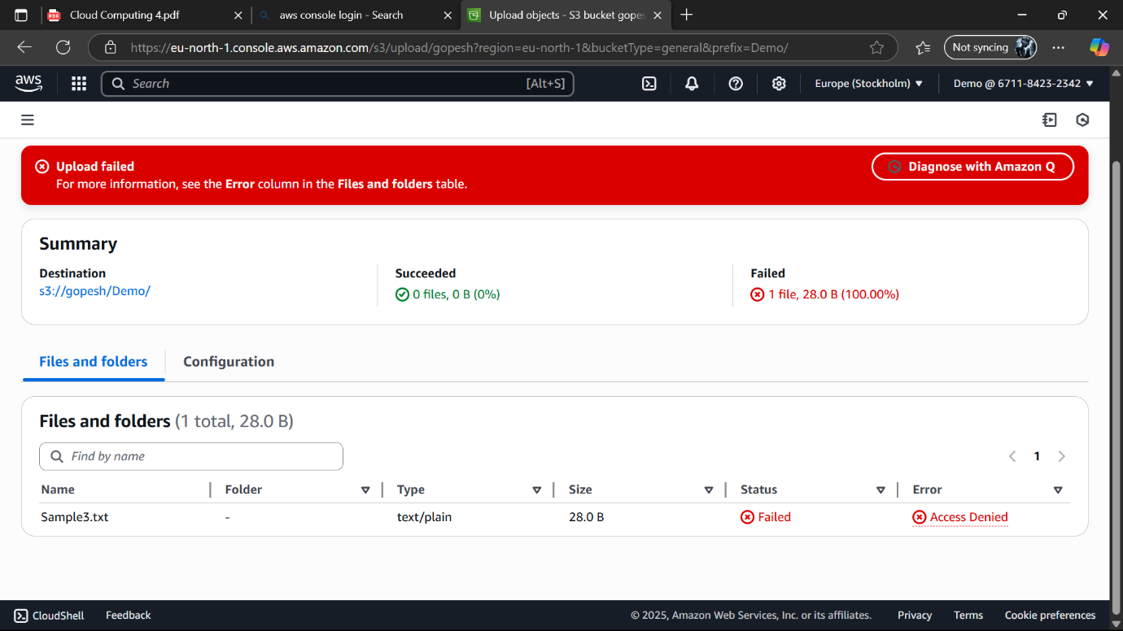

Edited bucket policy-

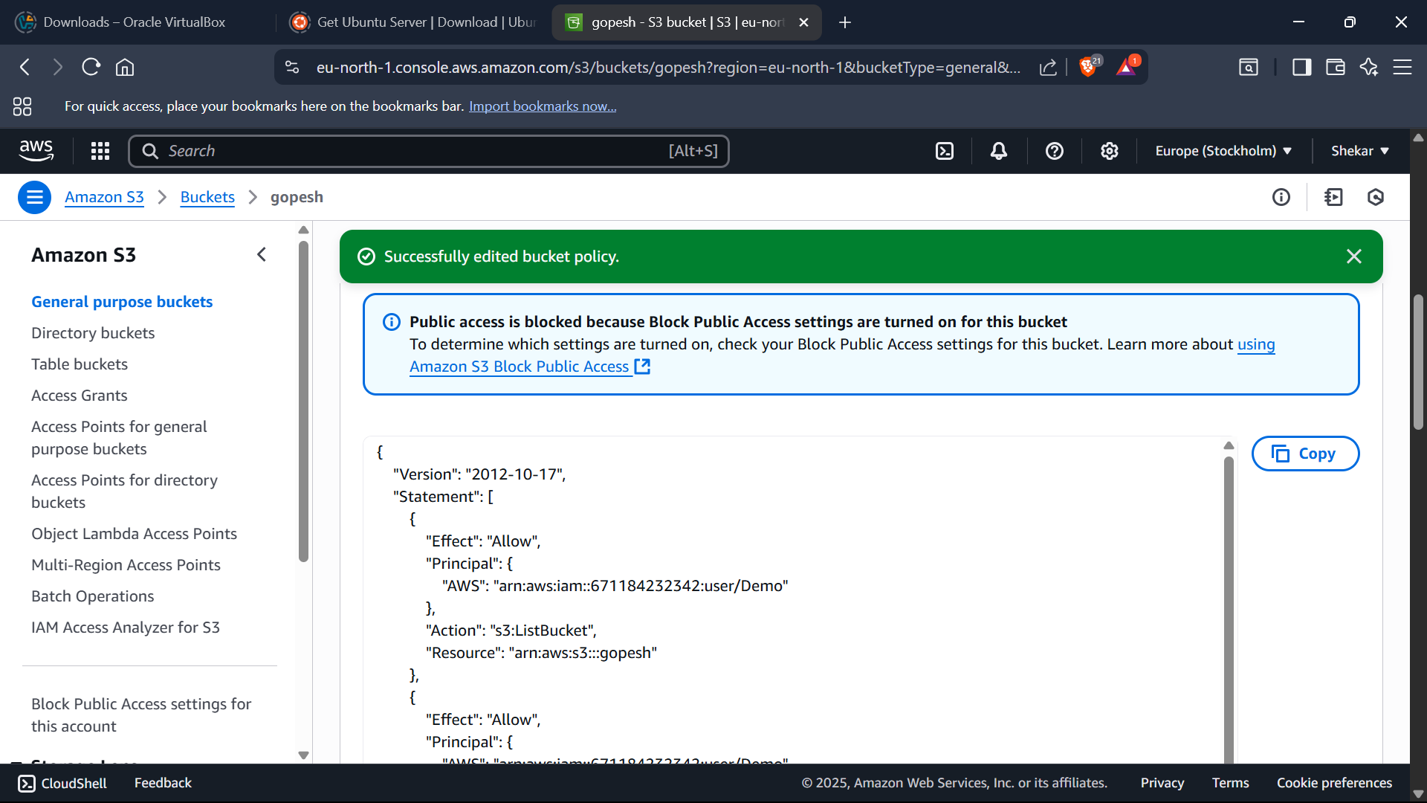

**Day-6 (07-07-2025)**

Introduction to Amazon EWS

Features –

* Allows you to dynamically increase capacity
* Attach them to Amazon EC2 instances
* Offer durable snapshot capabilities
* Allows you to optimize storage performance

Create a volume in the Rootuser-

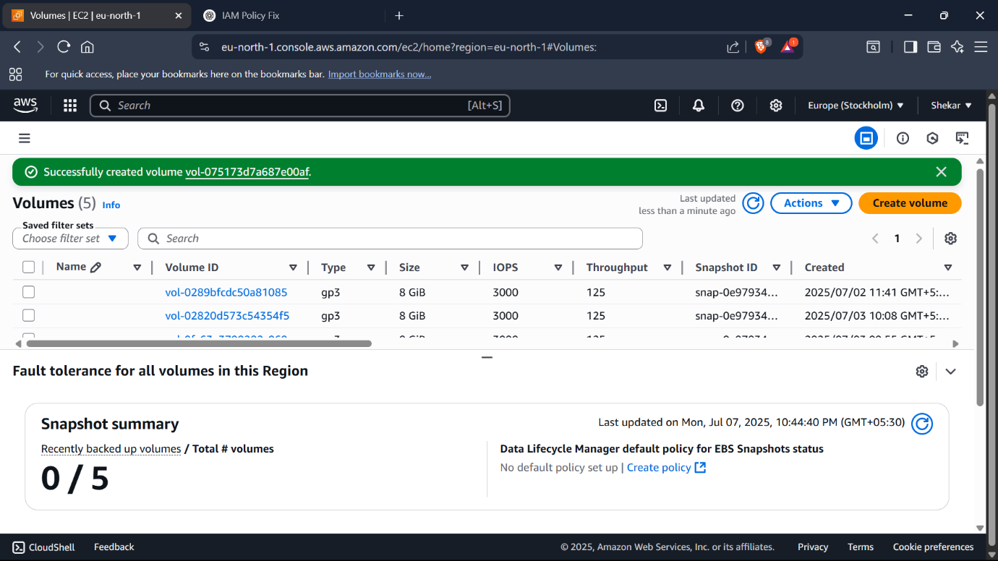

Attaching newly created volume to the instance-

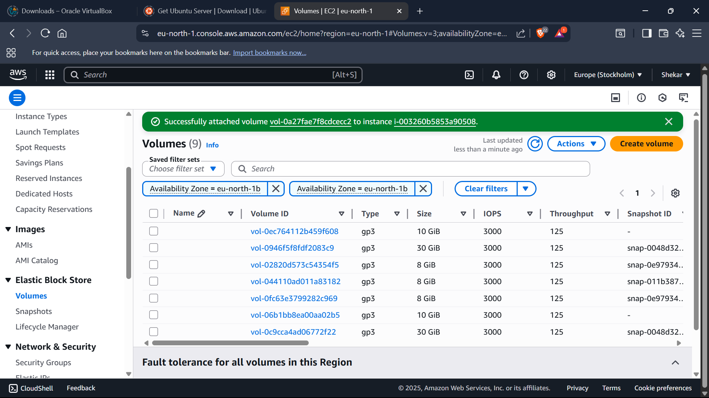

Initiating the launch of instance-

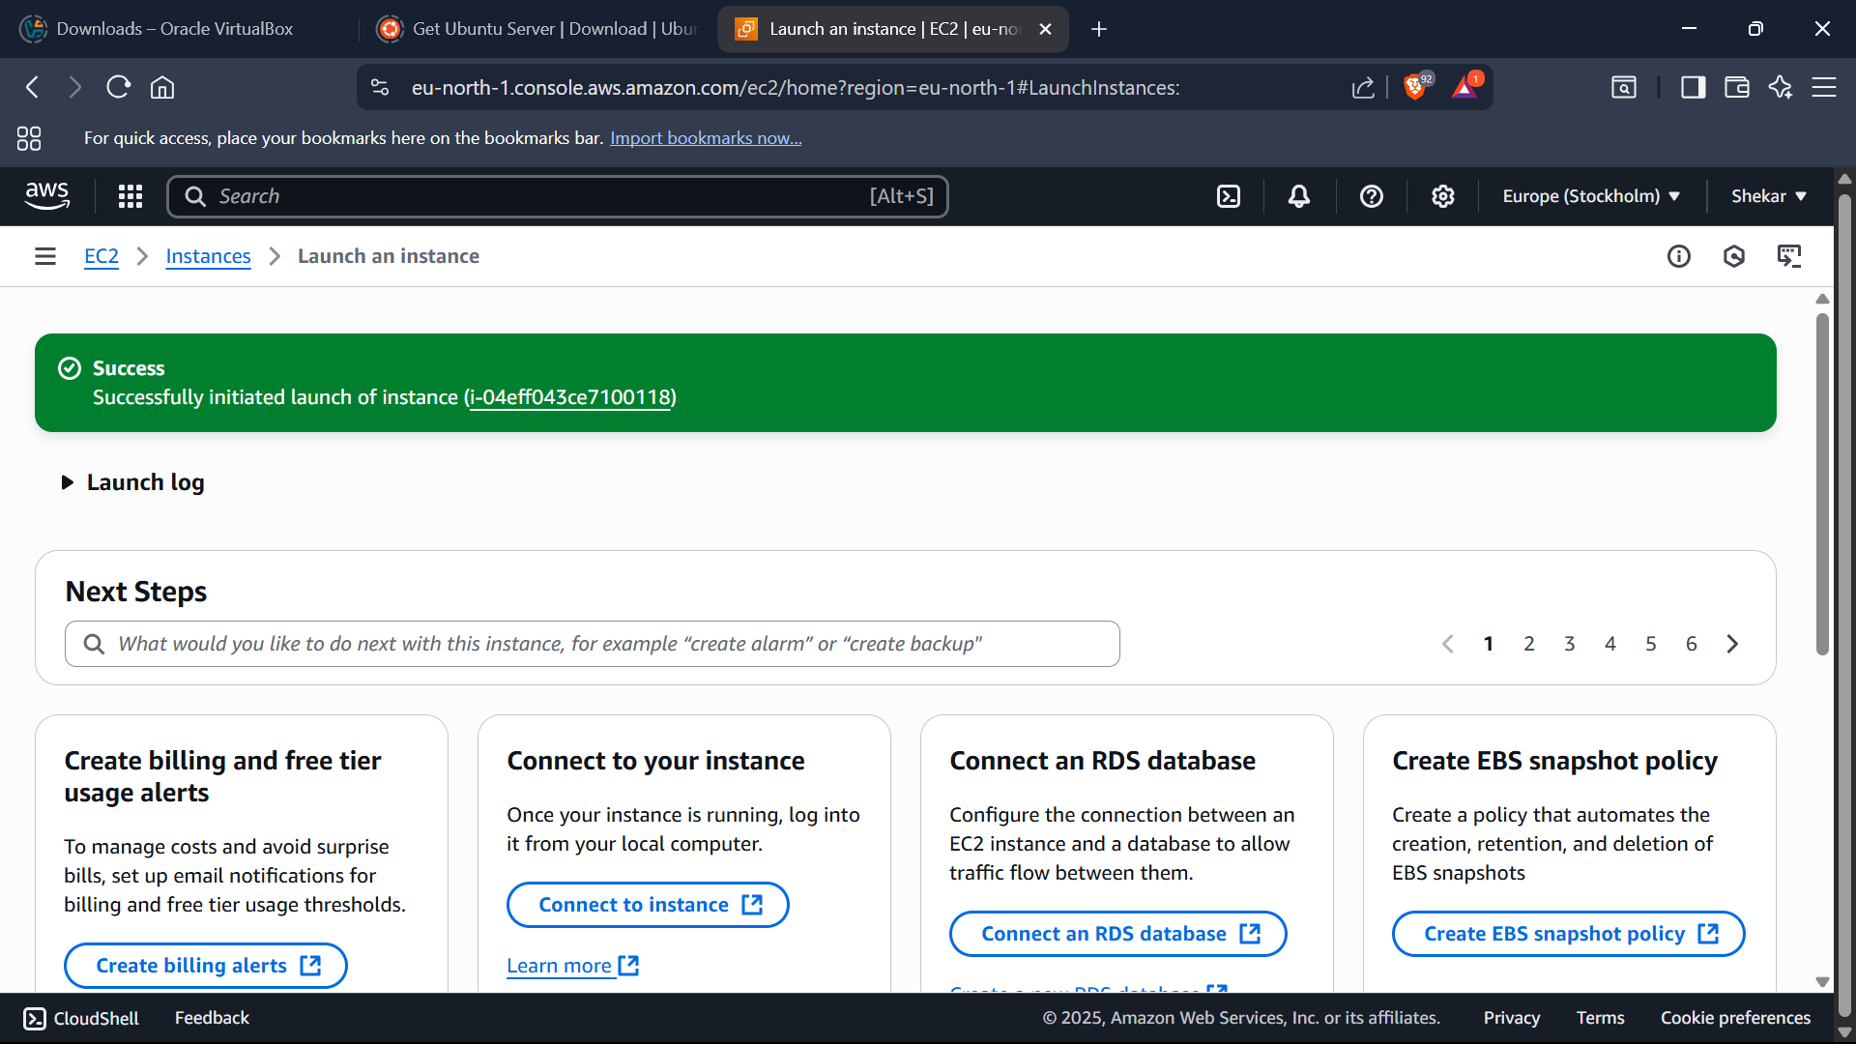

After intiating, we have to detach the volume-

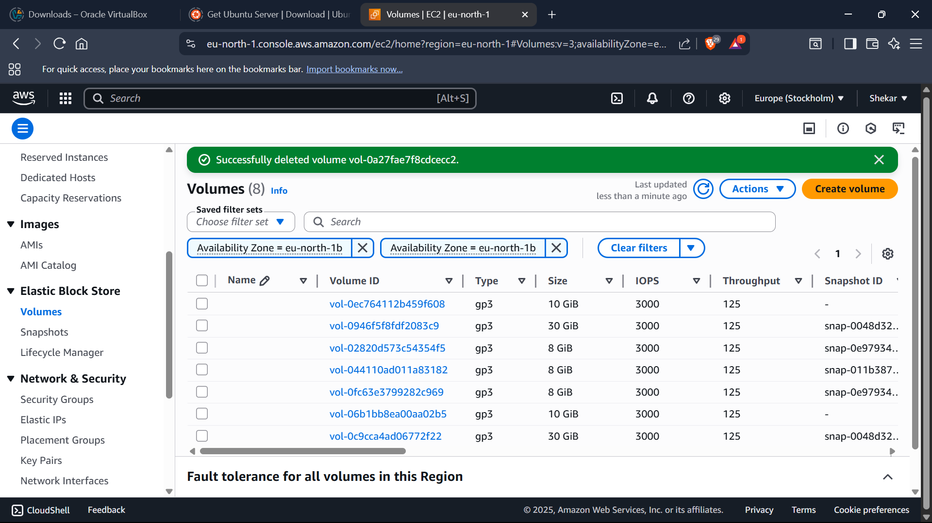

Then attach the volume to the instance-



Then we have to create a snapshot-

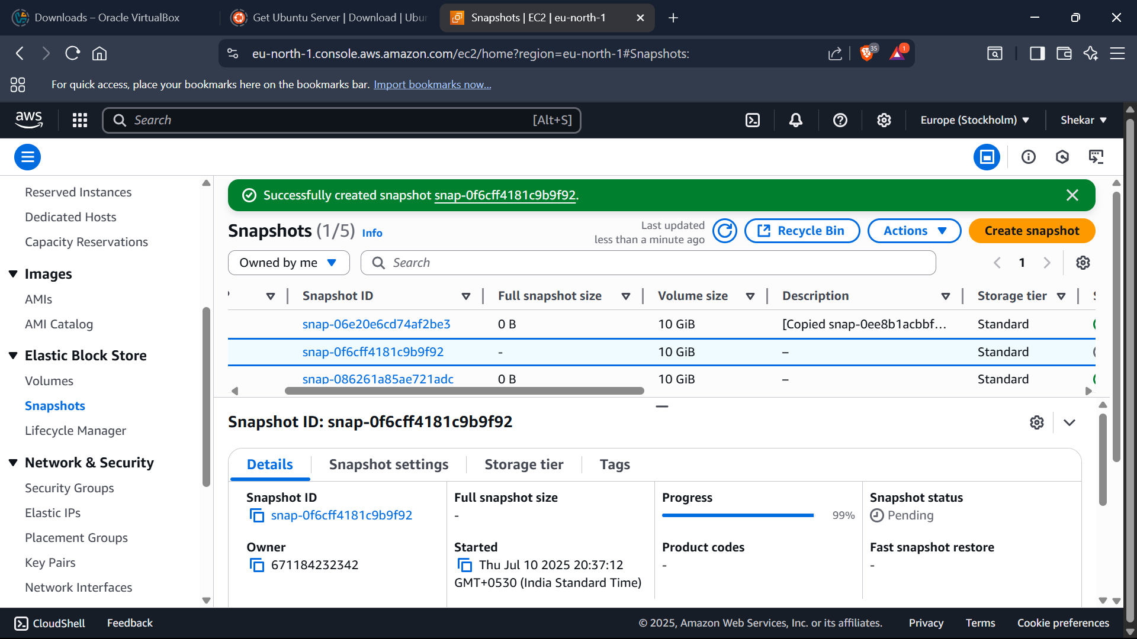

**Day-7 (08-07-2025)**

By the snapshot, we will create lifecycle policy-

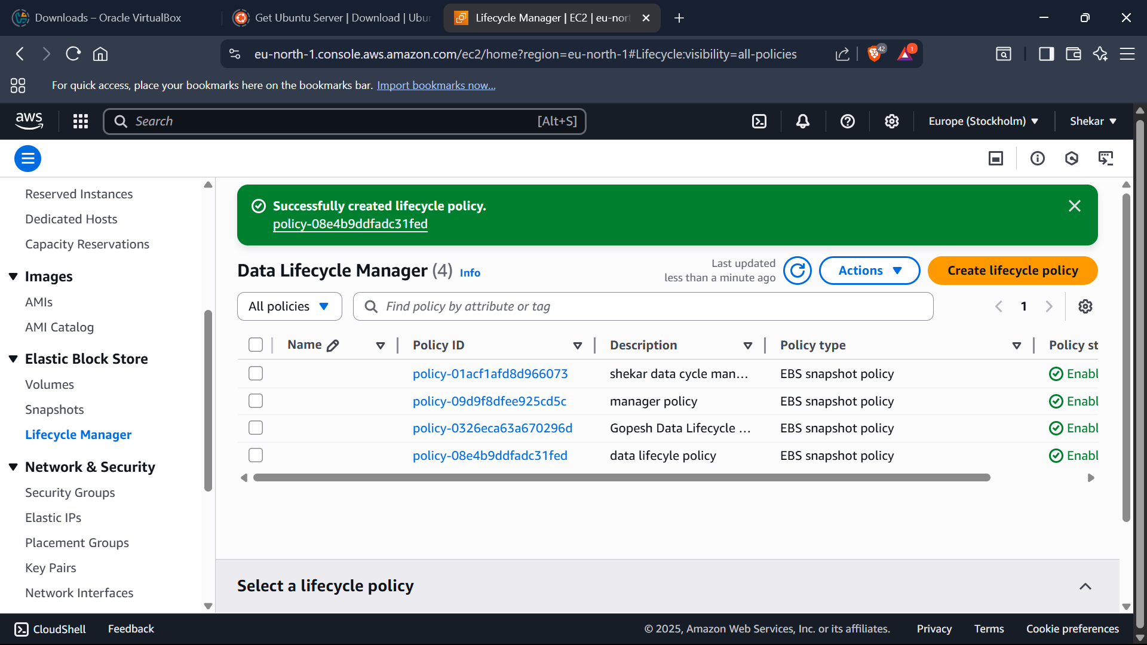

After creating it, we have to update the lifecycle policy-

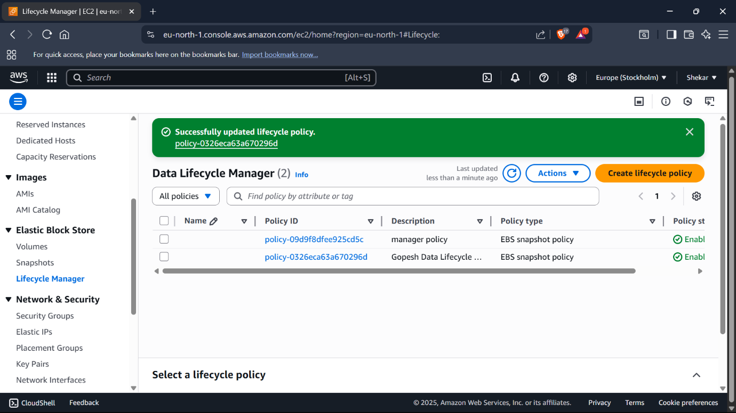

**Day-10 (11-07-2025)**

**Project Title – Secure Personal Cloud Storage System using AWS**

Progress Of Project –

Launching the EC2:

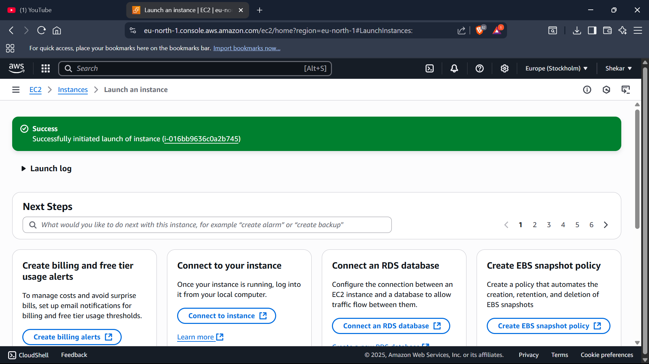

Configrating EC2 with the Ubuntu:

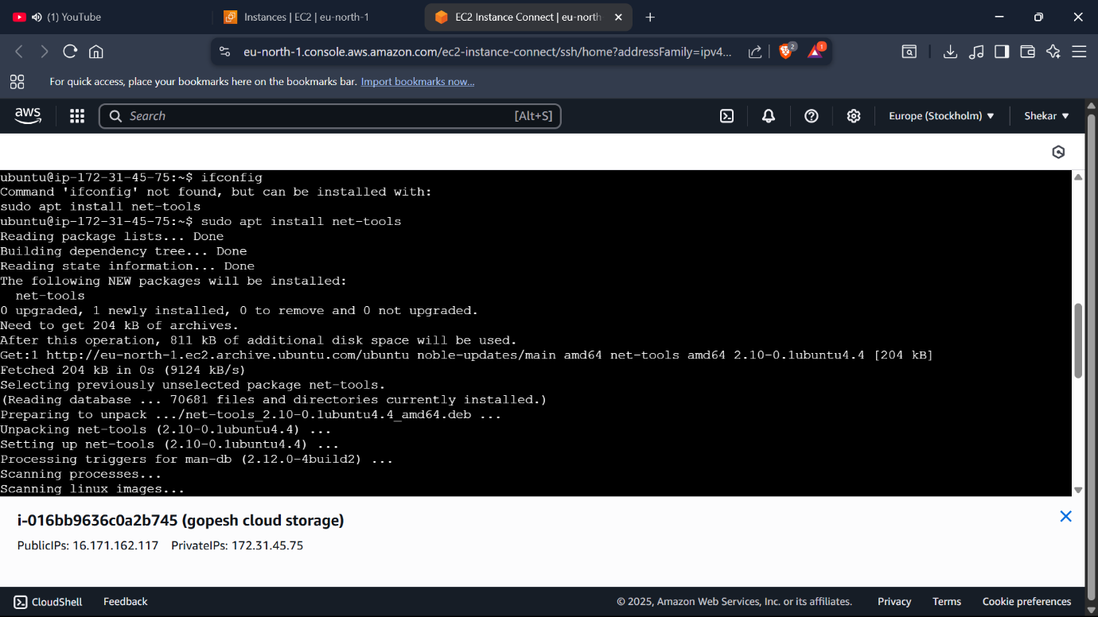

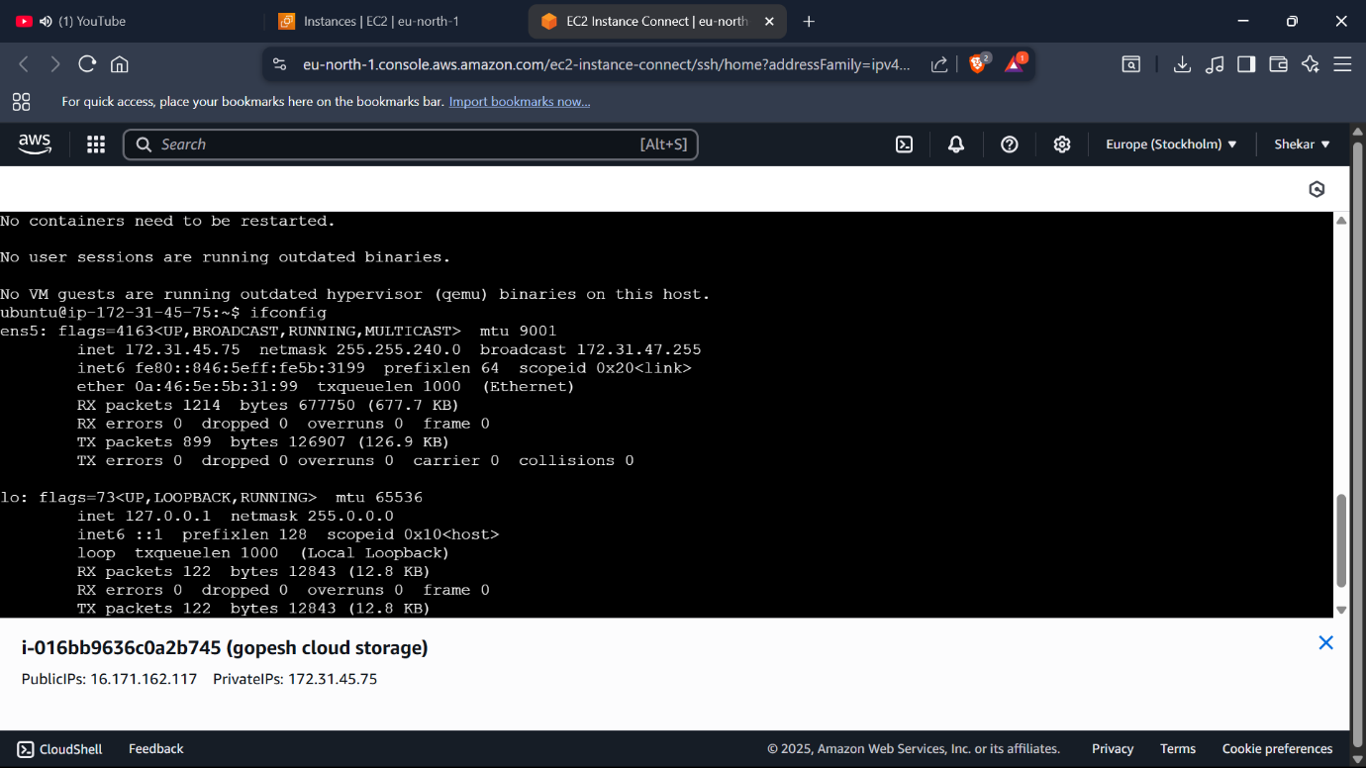

Creating an S3 Bucket:

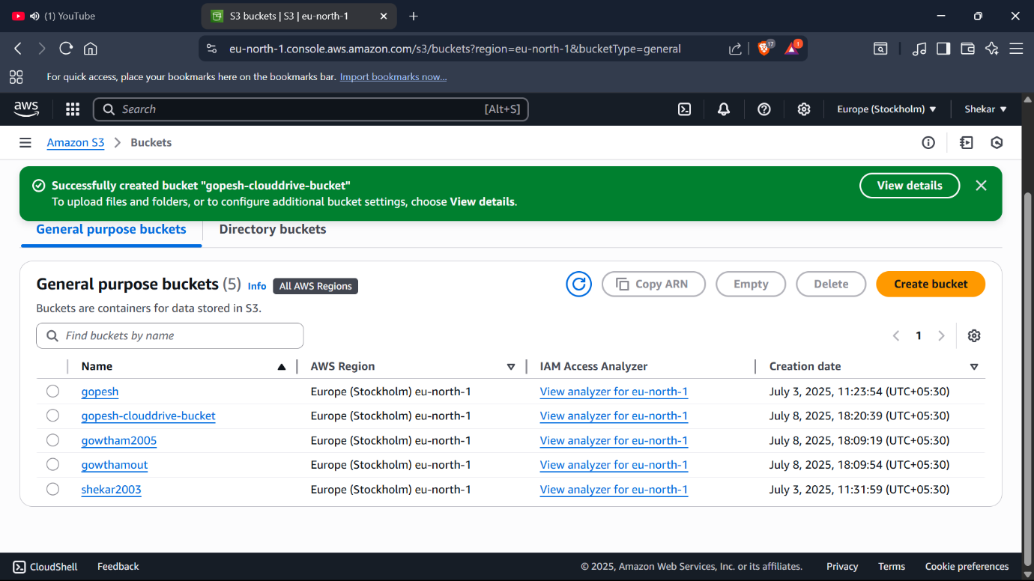

Editing the Bucket policy:

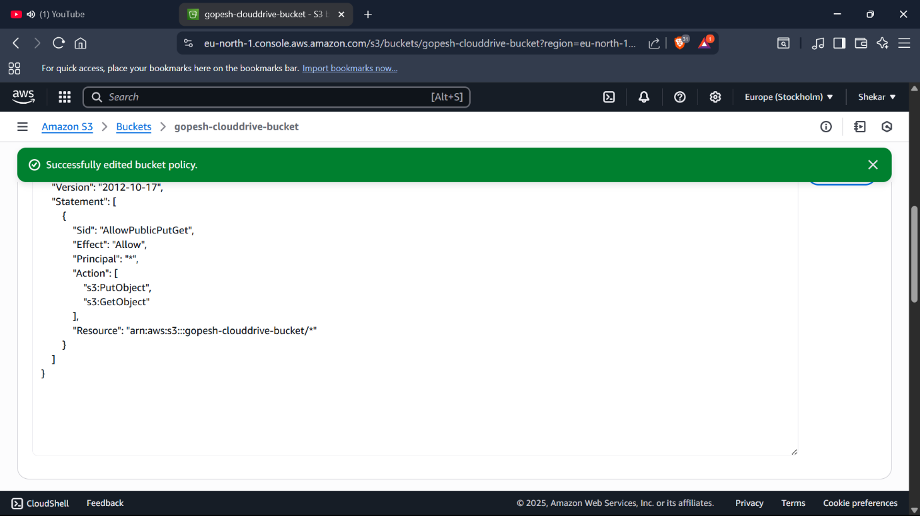

Using EC2 to access the file:

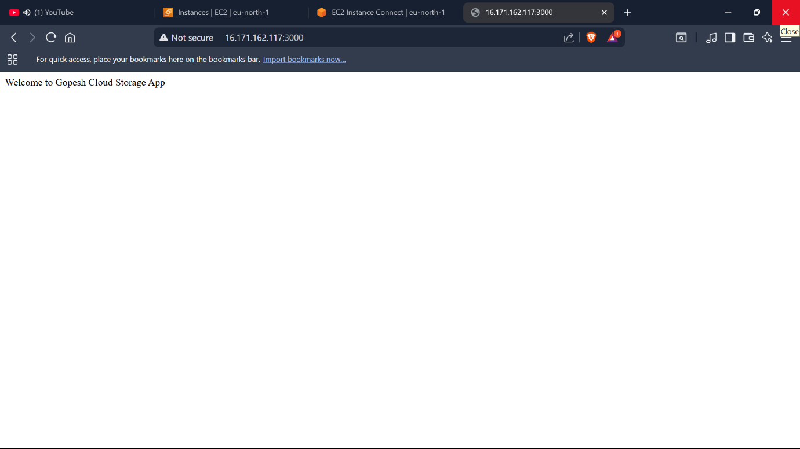

Using Aws Cognito for the Sign in process:

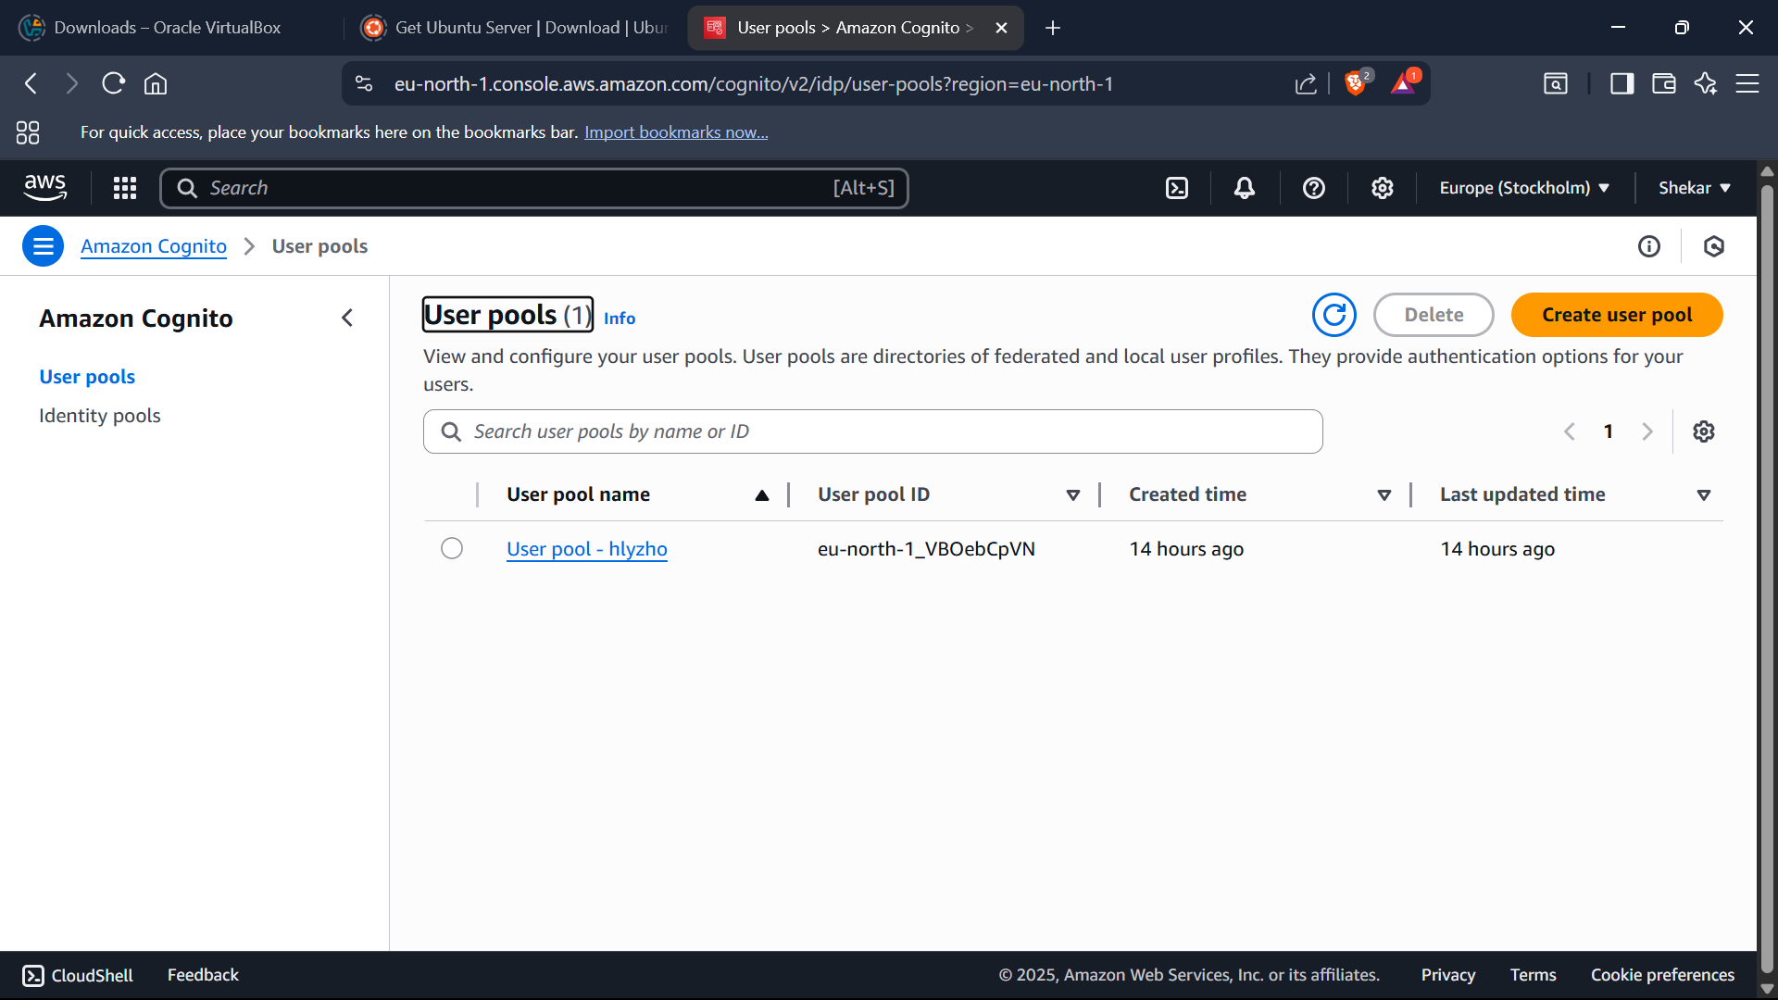

Creating a client in the pool:

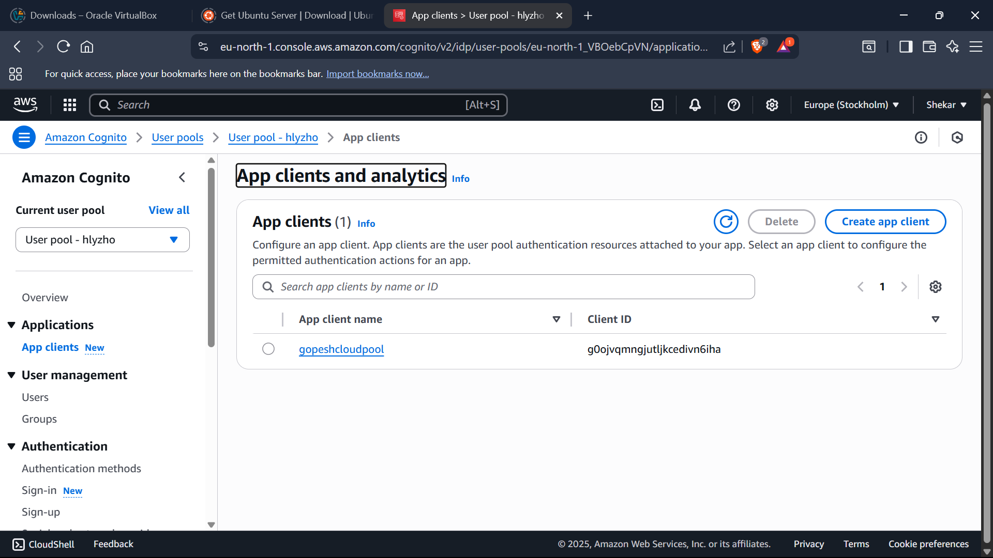

Creating a user:

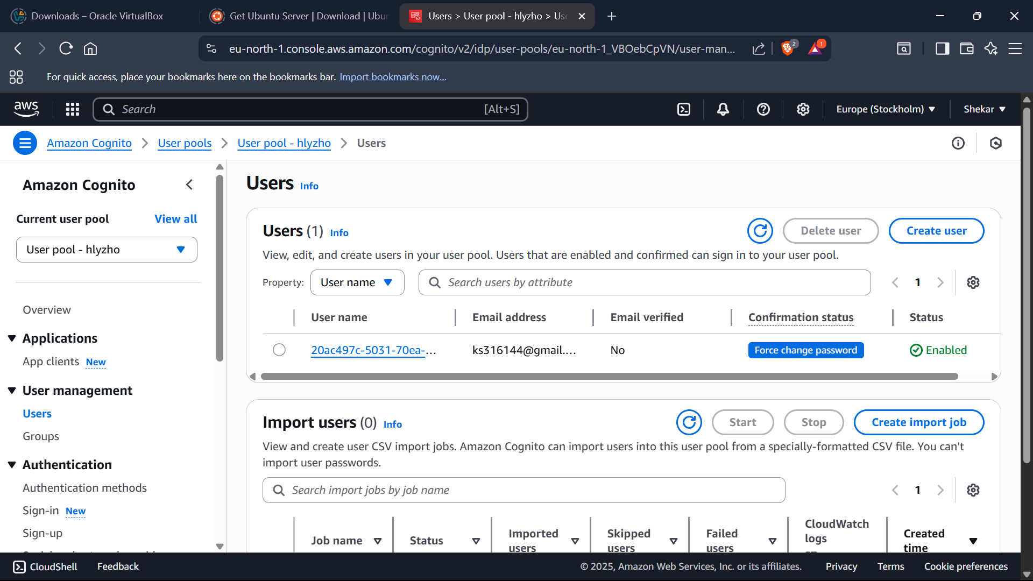

Using the domain for the cloud:

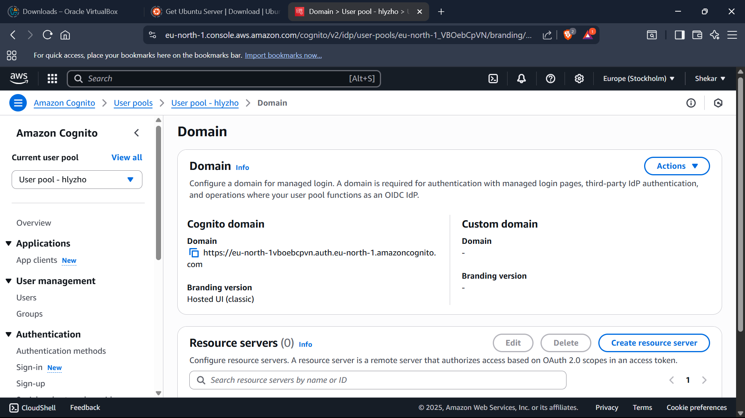

The interface of the cognito looks:

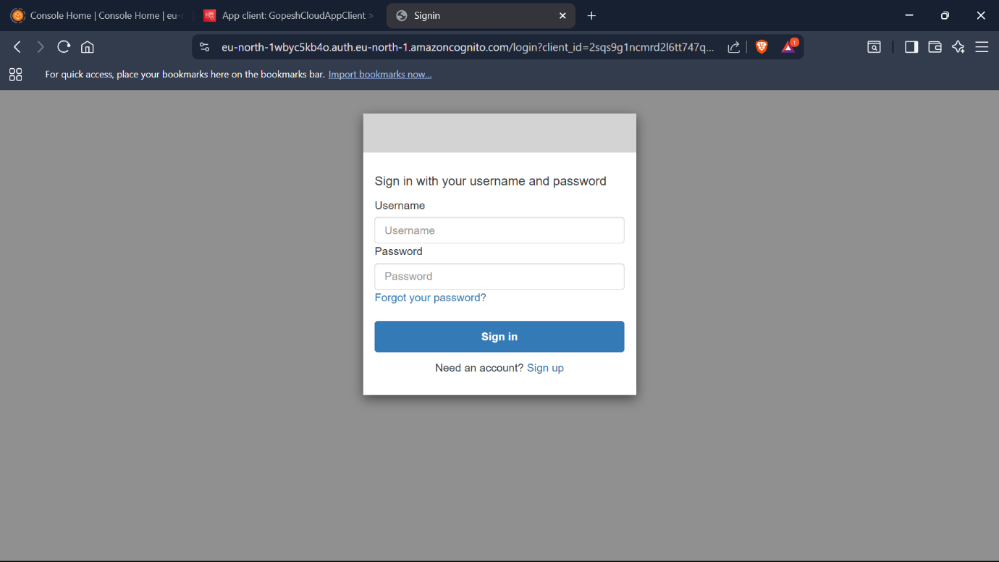

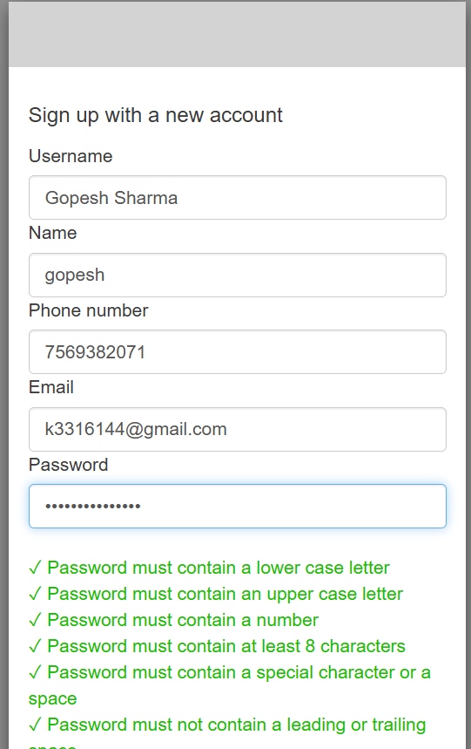

Creating a frontend and backend for the cloud:

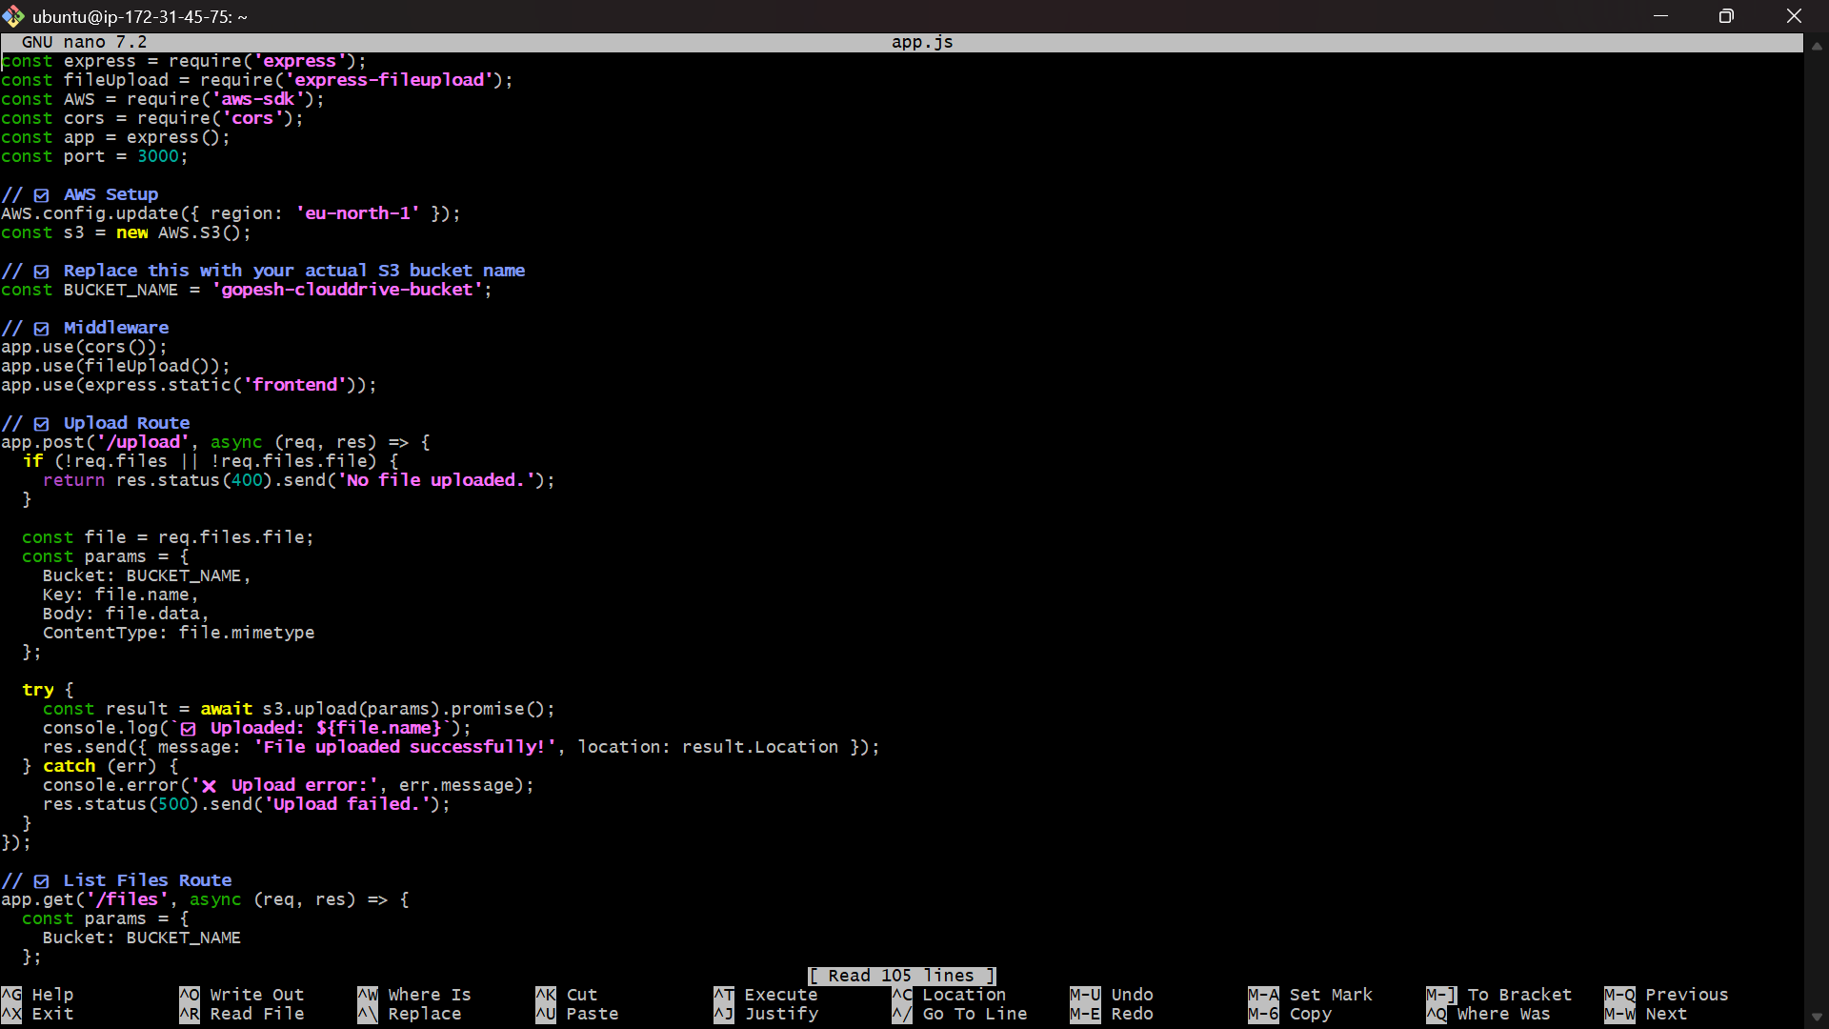

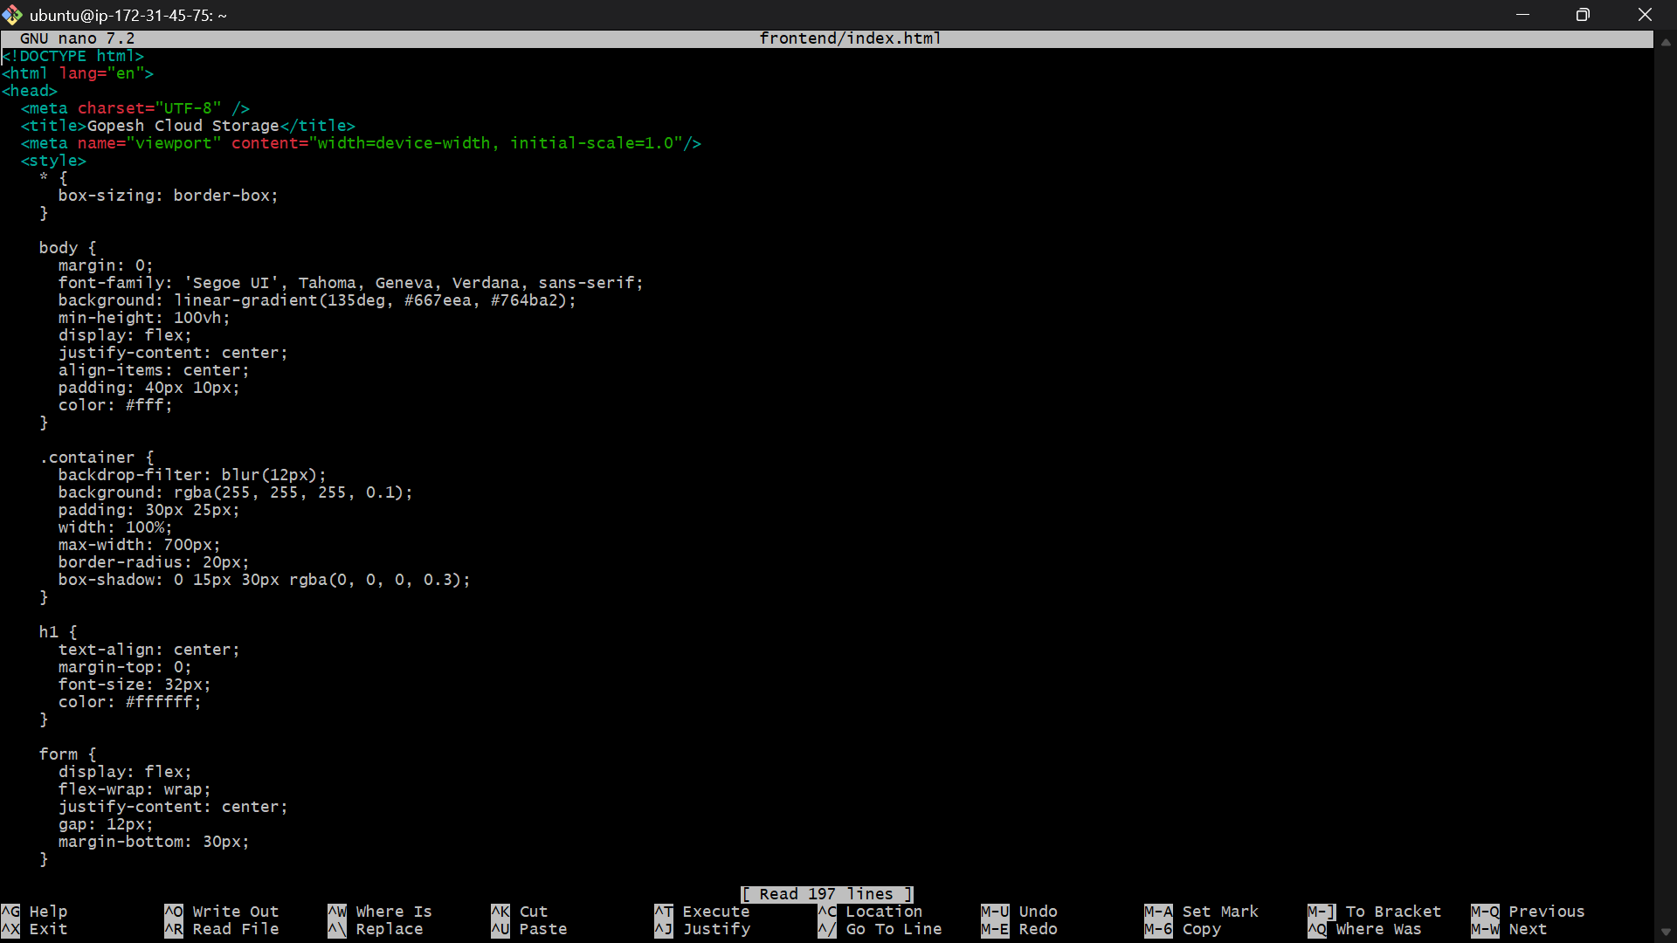

Running the URL:

http://16.171.162.117:3000

The cloud is appeared in this format:

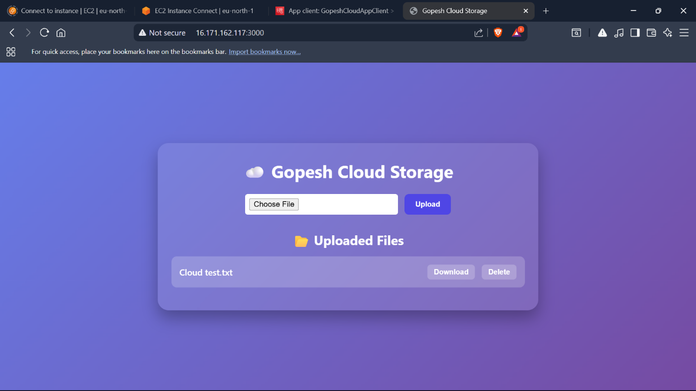

The file can be Uploaded, Deleted and downloaded: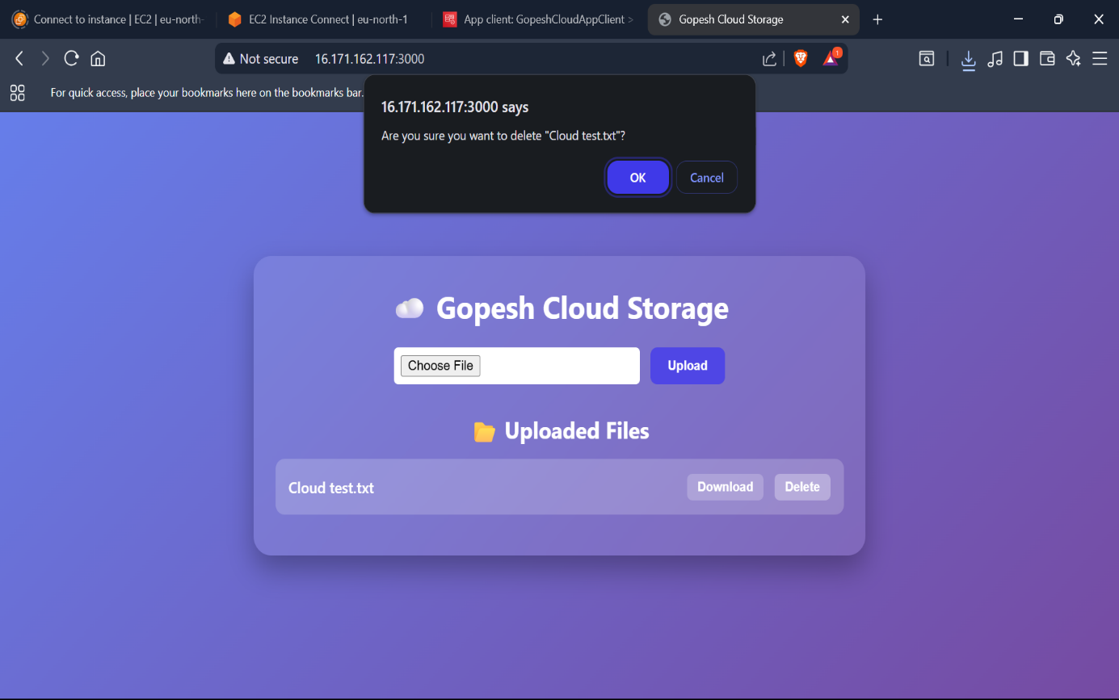

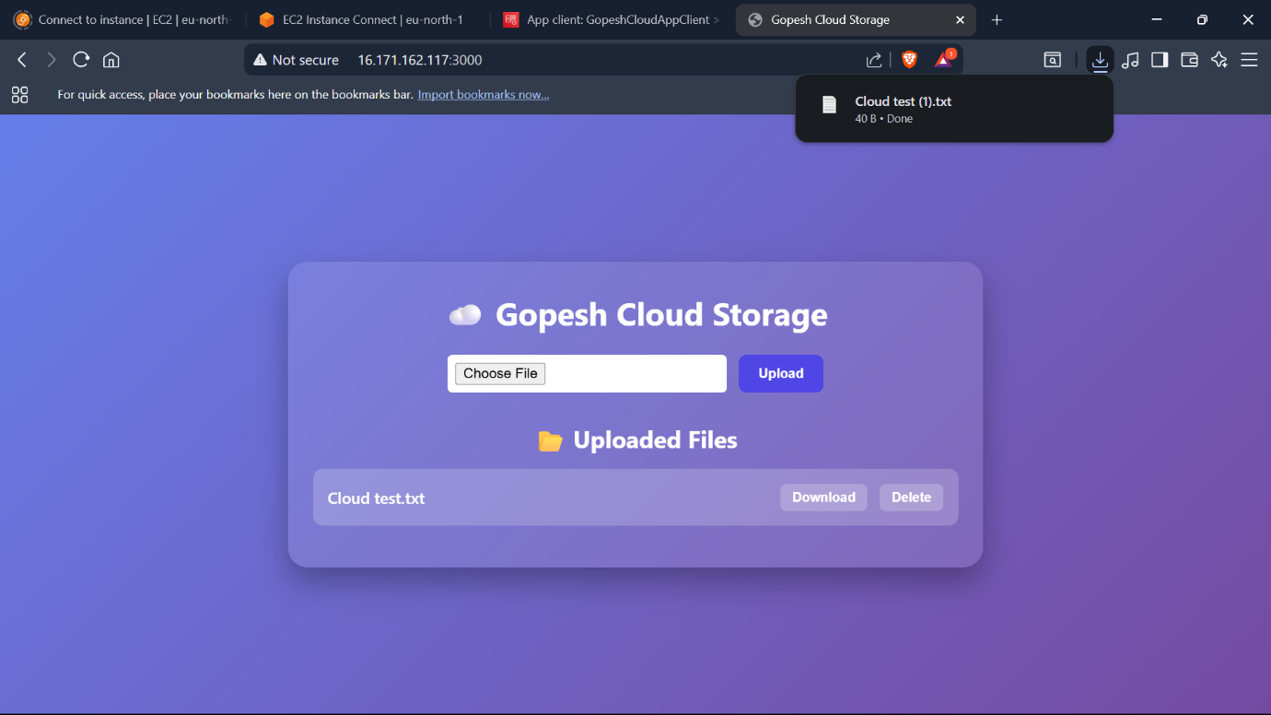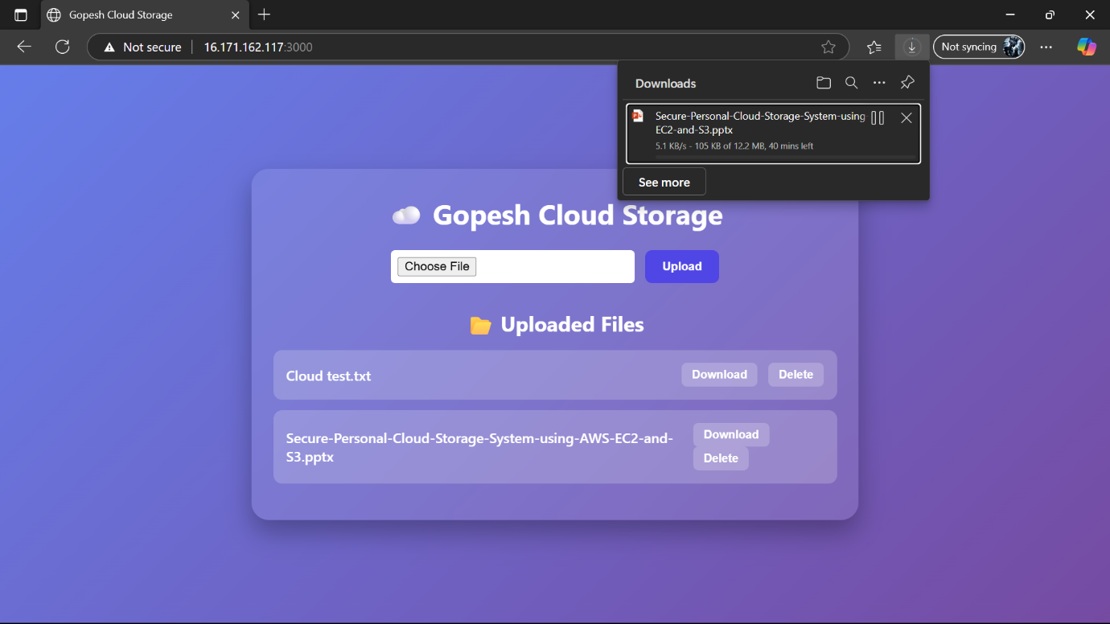

This the hole working of the project:

Thank You: